Marija Trifkovic

**Graphical User Interface Design for Retrieving and Viewing Massive Remote Sensing Data**

**Abstract**

Light Detection and Ranging (LiDAR) technology produces information about the shape and surface of an object or region. The scanner emits light beams, which reflect off the target’s surface. This technique gathers data sets with billions of points. Thus, storage, processing, and visualization of such data sets is computationally demanding. To resolve this issue, traditionally data sets have been gridded and divided into tiles. This data management strategy results in discontinuities and/or redundancies at tile boundaries and limits accuracy of data retrieval to a single tile. Consequently, a platform that allows precise data retrieval and avoids unnecessary data processing is needed.

This project focuses on developing a Graphical User Interface (GUI) for LiDAR data retrieval and visualization for such a system. The GUI is an access gateway to a distributed spatio-temporal database system. It allows selection of a two-dimensional area of interest and visualization of the three-dimensional model of that area. To improve the application, functionalities of data retrieval and visualization platforms have been identified and compared and one has been selected for implementation. The feature currently under development will offer information on area location and shape and location modification tools, preventing redundant information selection and ensuring desired point collection.

**Introduction**

One of the most commonly used remote sensing methods is Light Detection and Ranging (LiDAR). LiDAR technology uses beams of light in order to acquire a digital representation of an object or a region. A scanner, which can be static or mobile, emits light beams which reflect off the target’s surface. Information about all the reflection points is gathered and stored in a data set. Data sets gathered from this technique can have millions or billions of points depending on the density of the scan. These data sets can be used in order to obtain information about the shape and surface characteristics of an object or a region. In Figure 1, an image which represents the scanning process can be seen. Figure 2 representts an example of a 3D model gathered from LiDAR data.

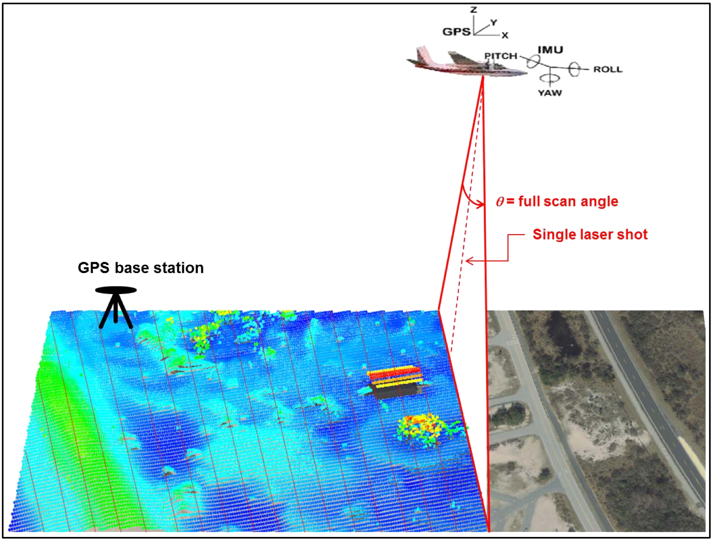

Figure 1: LiDAR scanning process [1]

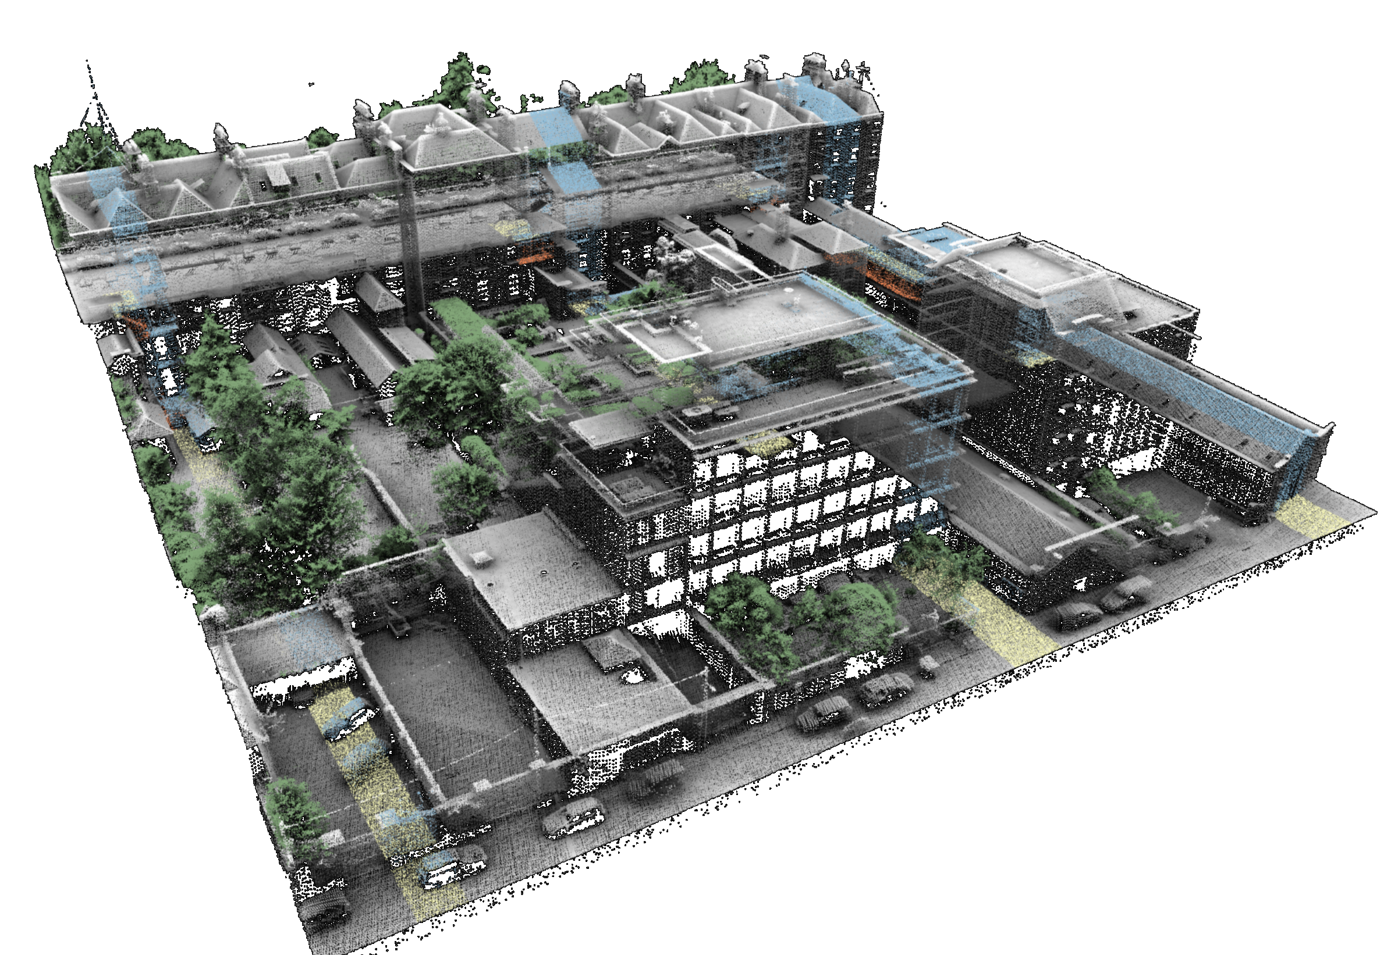

Figure 2: 3D model gathered from NYU CUSP LiDAR data [2]

**Background**

The United States Geological Survey (USGS) is currently conducting a plan called the 3D Elevation Program (3DEP) which is meant to cover the entire surface of the United States in LiDAR data. According to their July 2020 report, more than half of the intended surface has been covered. [3] Areas which have already been scanned can be seen in dark green in Figure 3. This project has resulted in tens of trillions of data points which are all publicly available. Data gathered from this project has several applications, such as preventing flooding. Its importance can be inferred by the one billion dollar investment in this project. The collected data sets are shown on the USGS website in a list of available files. Numerous organizations, including USGS, have made web applications which allow for a more convenient way of retrieving data from their database by providing a map which visualizes the position of data sets. An example of such web application can be seen in Figure 4. This has resulted in an easier way to retrieve a desired data set. However, data sets are massive and often not necessary in their entirety to the user.

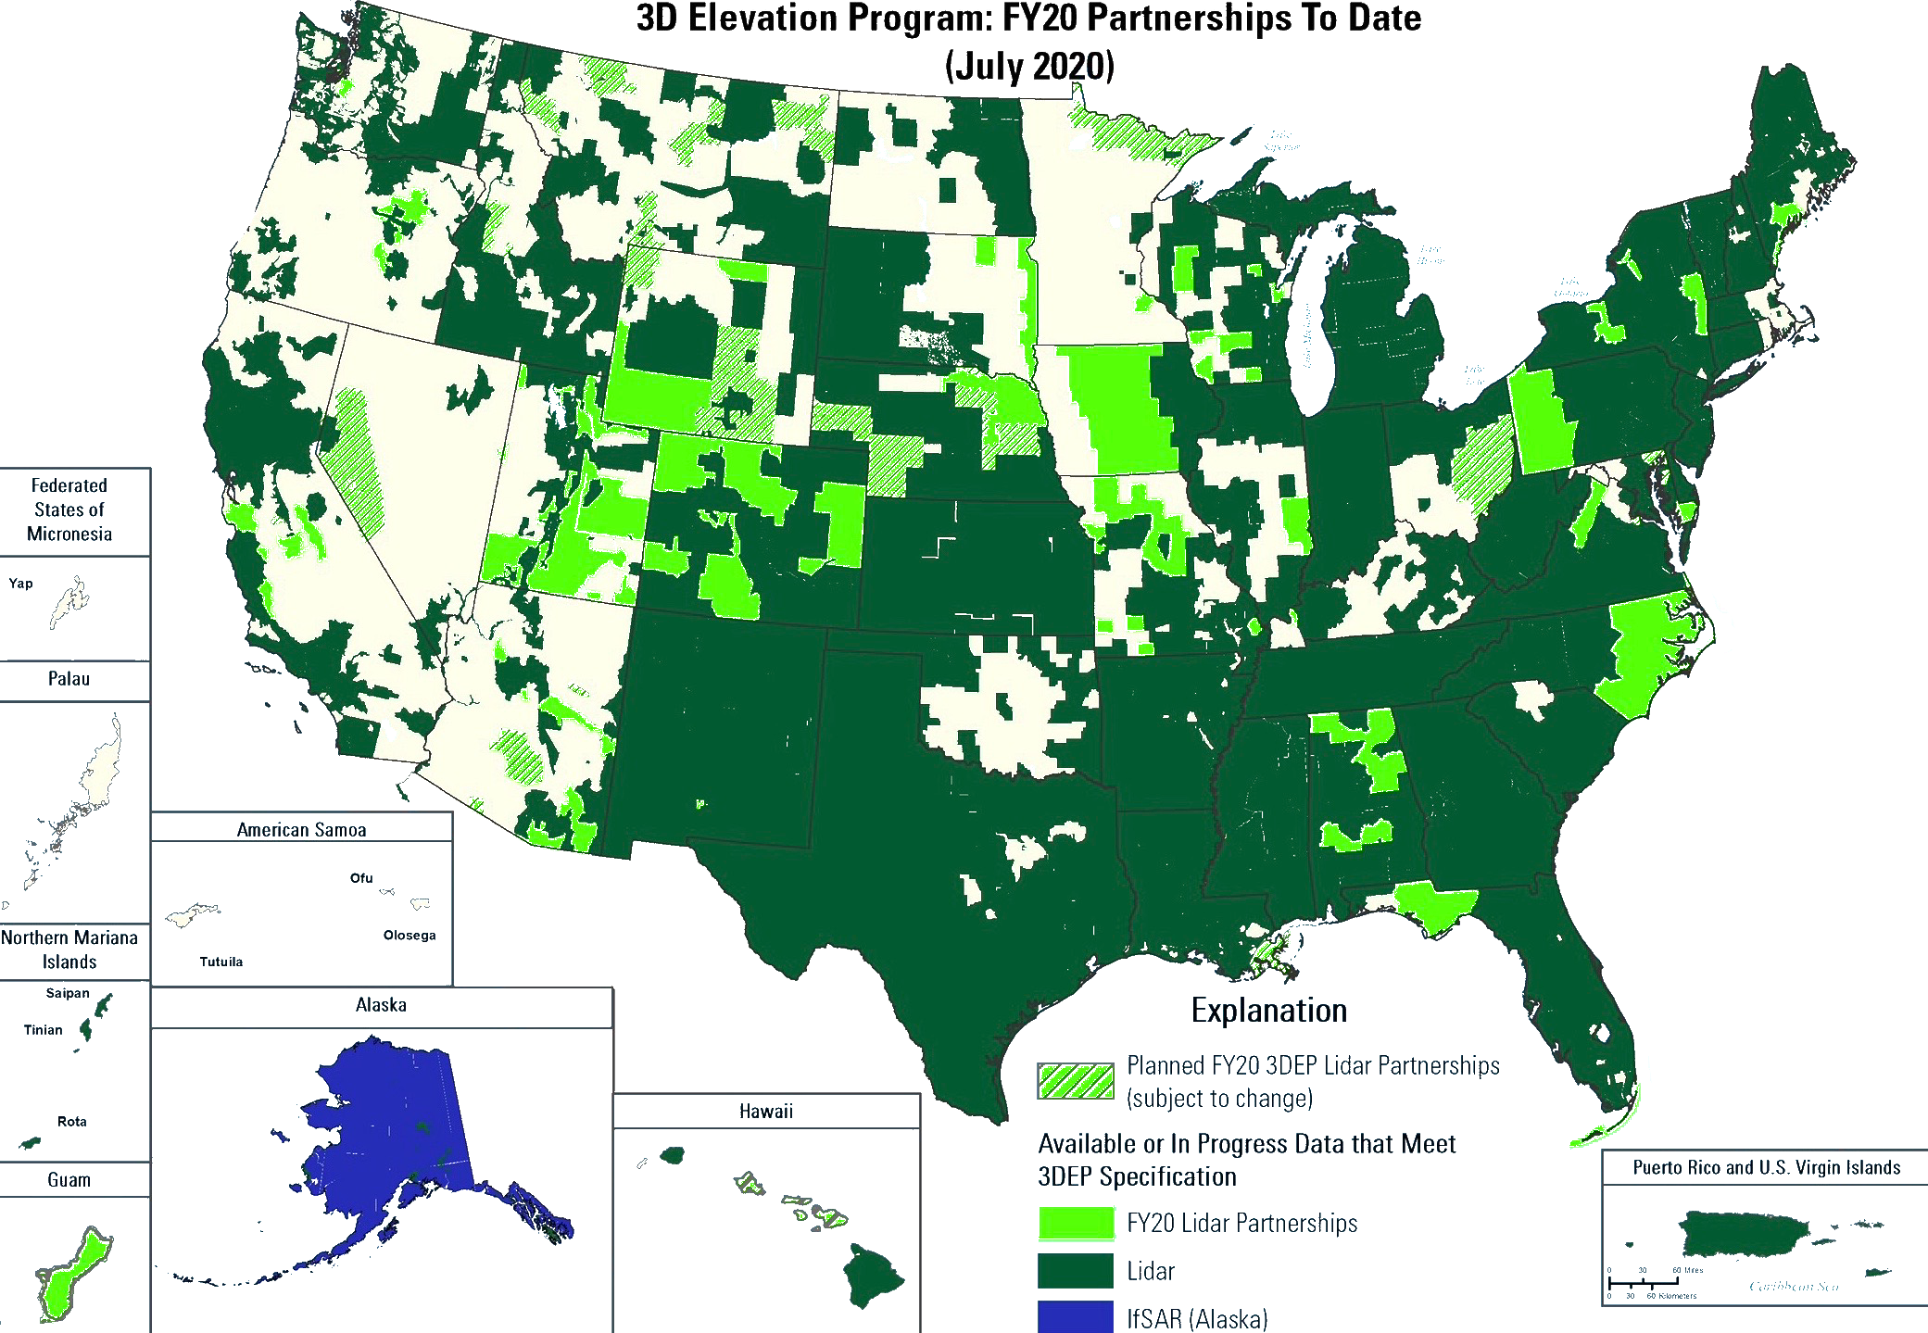

Figure 3: USGS map of LiDAR covered territories [3]

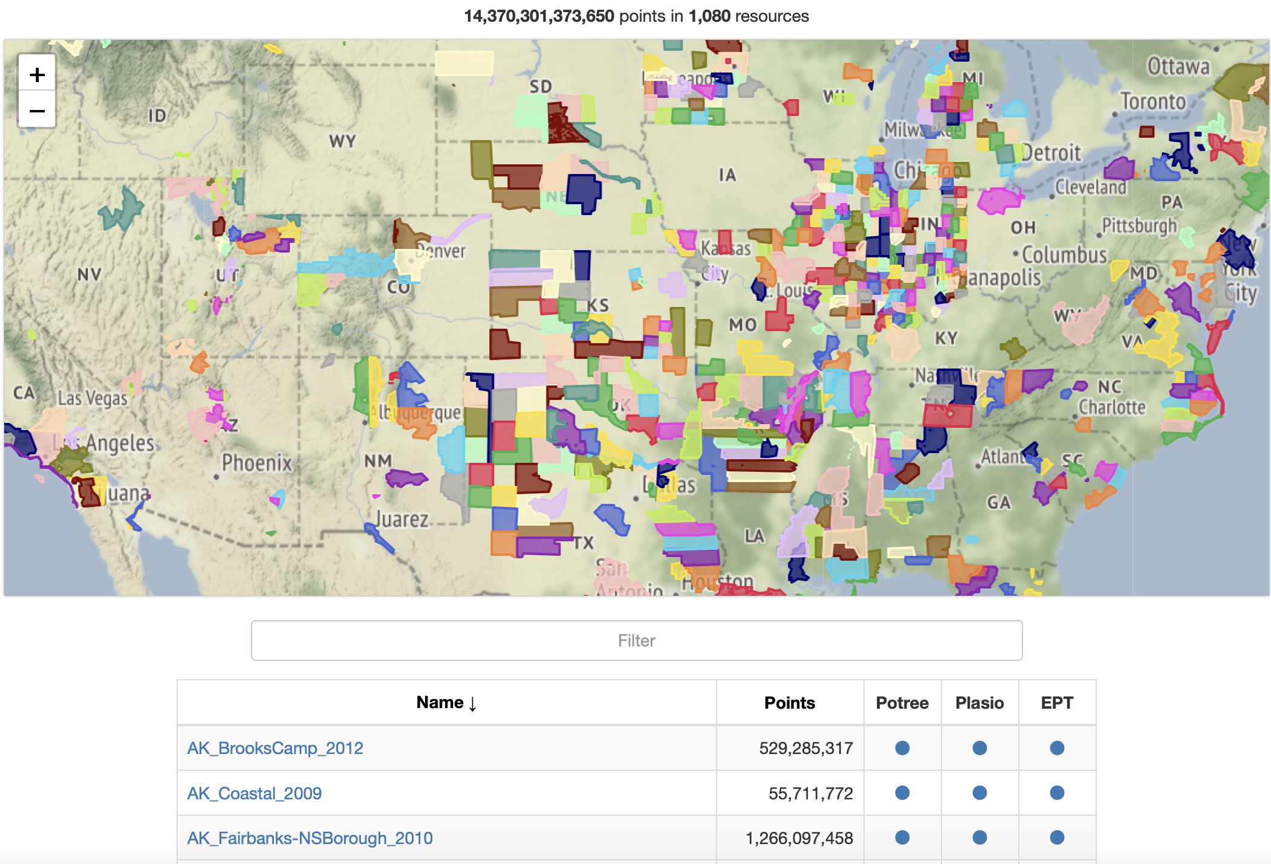

Figure 4: USGS data visualization map [4]

This is why some organizations, such as the New York State Department of Information Technology and Telecommunications (DoITT), have divided their data sets into tiles by using a grid. Each tile is a square whose location can clearly be located on their web map. The DoITT’s web map can be seen in Figure 5.

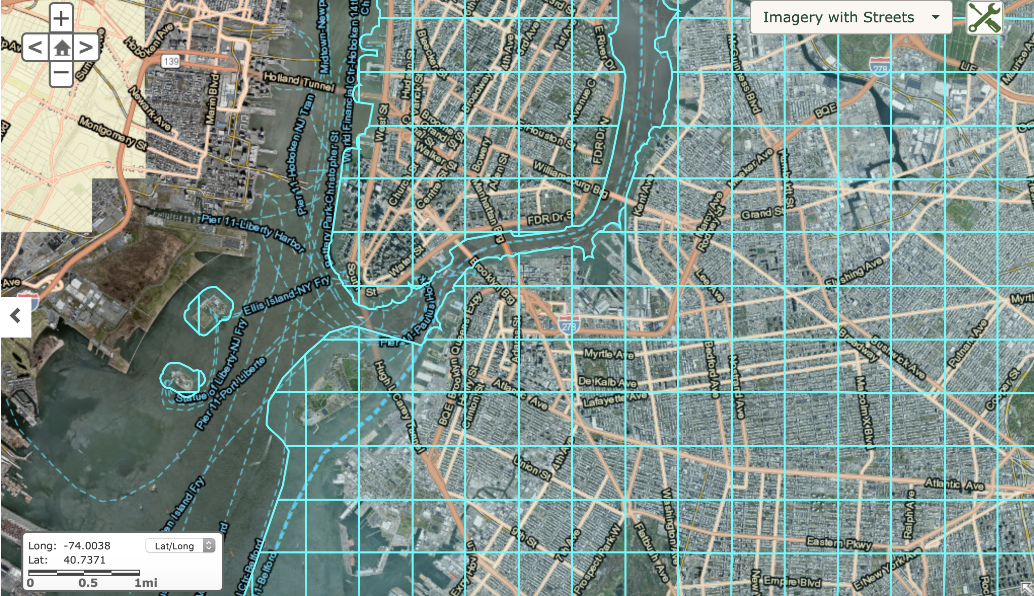

Figure 5: DoITT’s web map [5]

This technique for data management allows users to retrieve smaller pieces of data which correspond to their area of interest. One of the problems that arises from this technique is that a user might only be interested in a small area between two tiles. If this was the case, the user would have to retrieve data corresponding to two tiles which results in a big number of unnecessary points being downloaded. An example of this situation can be seen in Figure 6 where a user might only be interested in the building in the red circle but has to retrieve data from both tiles the building is in.

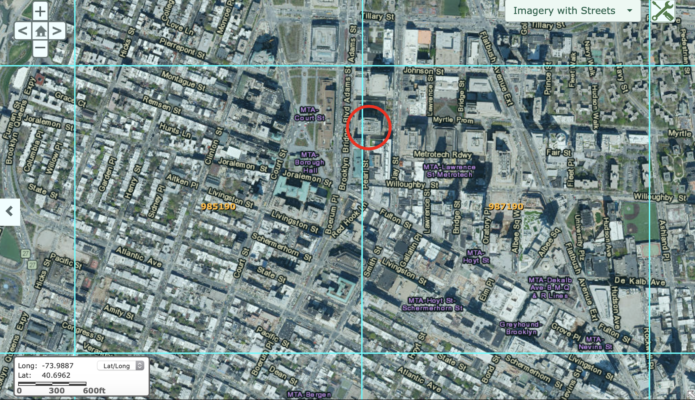

Figure 6: Two tiles on DoITT’s web map [5]

**Scope & methods**

This is why there is a need for an application which allows for selection of a specific area of interest and retrieval of data corresponding only to that area. A prototype for such an application has been created and efforts have been undertaken in order to improve the application.Currently available GUIs have been investigated in order to gather information about techniques and tools that are commonly used and most helpful. Since the initial GUI prototype has two main functionalities, retrieving and viewing data, the investigated GUIs were initially divided into two main categories: those for data visualization and those for data retrieval. It can be inferred that there are few GUIs that offer both of these functionalities, which is why the category of a GUI can easily be determined. After finding GUIs from both categories, those interfaces were closely inspected and most commonly used tools that each of them offered were noted. This resulted in Table 1 where some of the most commonly used data viewing applications can be seen. There is a noteworthy number of frameworks which are not web based. These kinds of platforms are often only supported by the Microsoft Windows Operating System which massively narrows the amount of people who can use them. All of the frameworks in the table are web based except for CloudCompare. Another important observation to make is the fact that web based applications do not necessarily secure complete inclusivity as some only work on specific web browsers (for example, Google Chrome). Additionally, Actueel Hoogtebestand Nederland 2 (AHN2) [6] is a framework which allows for viewing the entire Netherlands data set which puts it in both the visualization and retrieval category. However, that is the only data set that can be retrieved, which is why AHN2 was put into the visualization category. It is crucial to mention that AHN2 uses Potree [7] for their GUI, which is why there is a similarity between their functionalities. Similarly, speck.ly [8] uses plas.io [9] but their interfaces are different in appearance and user flow which is why they were both inspected.

|  |  |  |  |  |  |  |
| --- | --- | --- | --- | --- | --- | --- |
|  | Potree | CloudCompare | Plas.io | speck.ly | lidarview.com | AHN2 |
| Rotate | x | x | x | x | x | x |
| Zoom | x | x | x | x | x | x |
| Move | x | x | x | x | x | x |
| Background | x | x |  |  |  |  |
| Color | x | x | x | x | x | x |
| Field of view | x | x | x |  |  | x |
| Camera type | x | x | x |  |  |  |
| Point size | x | x | x | x | x | x |
| z-exaggeration |  |  | x | x |  |  |
| Intensity |  |  | x | x |  |  |
| Eye-dome lighting | x |  |  | x |  |  |
| Inundation plane |  | x | x | x |  |  |
| Point density | x | x | x | x |  | x |
| Rotation center |  | x |  |  |  |  |
| Point picking | x | x |  |  |  |  |
| Set view | x | x |  |  |  |  |
| Point distance | x | x |  |  |  | x |
| Angles | x | x |  |  |  | x |
| Height difference | x |  |  |  |  |  |
| Measure circle | x |  |  |  |  |  |
| Measure area | x |  |  |  |  | x |
| Measure volume | x |  |  |  |  | x |
| Align clouds |  | x |  |  |  |  |
| Extract clouds |  | x |  |  |  |  |
| Control switch |  |  |  |  |  | x |
| Hovering speed |  | x |  |  |  | x |
| Grid |  | x |  |  |  | x |

Table 1: Common tools in data visualization GUIs

Next, the GUIs were ranked based on ease of use and number of tools they offer. The convenience rankings can be seen in Table 2.

|  |  |  |
| --- | --- | --- |
| Place | GUI | Score (out of 10) |
| 1. | plas.io | 9 |
| 2. | lidarview.com | 9 |
| 3. | speck.ly | 8 |
| 4. | Potree | 6 |
| 5. | AHN2 | 5 |
| 6. | CloudCompare | 3 |

Table 2: Convenience scores for data visualization GUIs

Plas.io has a short explanation underneath every tool and a help button which leads to video instructions which makes for a very convenient way to work with many available tools. On the other hand, lidarview.com [10] does not have a lot of tools, which means there is no need for many instructions. However, there is a top bar with a user guide. Speck.ly is similar to plas.io, but some tools are missing instructions which is why it ranks below. Potree has names of most tools written in the control panel which makes for easier use of the GUI. Since Potree has a lot of tools available, not all of them can be named in the control bar and none of them have any additional instructions. AHN2 only has icons for representation of functionalities. However, there are few tools and all of them are explained in a user guide. CloudCompare [11] ranks the lowest on this list because it is a much more sophisticated framework than all of the previously mentioned ones. It has numerous tools which are all represented by icons that are often hard to recognize. There is little text providing help in the GUI. Because of its complexity, CloudCompare has extensive documentation on their website which guides the user.

The functionality rankings can be seen in Table 3.

|  |  |  |
| --- | --- | --- |
| Place | GUI | Score (out of 10) |
| 1. | CloudCompare | 9 |
| 2. | Potree | 7 |
| 3. | AHN2 | 6 |
| 4. | speck.ly | 5 |
| 5. | plas.io | 4 |
| 6. | lidarview.com | 3 |

Table 3: Functionality scores for data visualization GUIs

As previously mentioned, CloudCompare has many functions for handling single and multiple data sets which makes it the GUI with the most functionality. Potree allows for a more detailed look at measurements of the 3D model than any other examined GUI which is why it is in second place. AHN2 uses Potree, but does not provide all of their tools and has less measuring options. Speck.ly can view multiple layers (for example, color and elevation) at the same time. This puts it above plas.io which allows for a basic analysis of the data as shown in Table 1. Lidarview.com has few functionalities which put it at the end of this list.

These ranks from Table 2 and 3 were used to establish a scoreboard which can be seen in Figure 7.

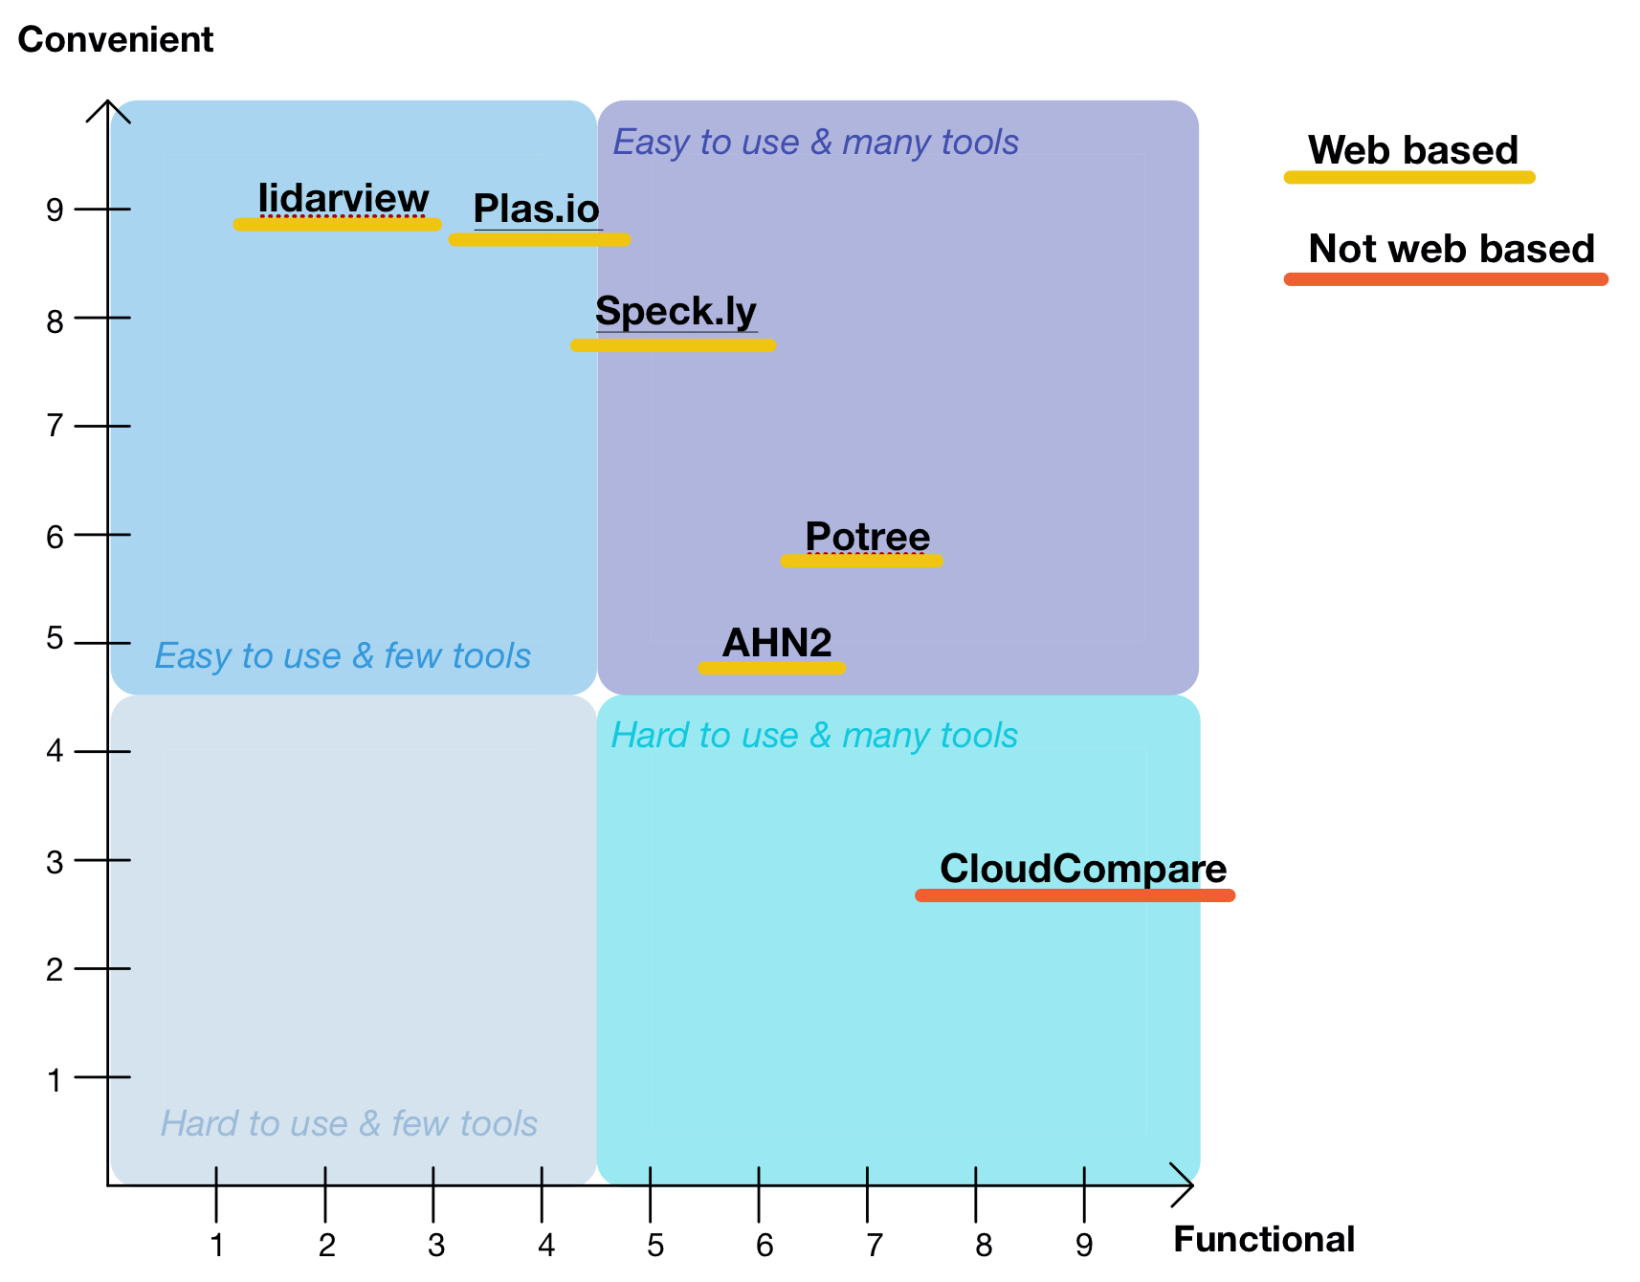

Figure 7: Overall score board for data visualization GUIs

A similar analysis was done on GUIs for data retrieval. The initial overview of the applications can be seen in Table 4. Some of the examined data retrieval GUIs have options for specific area selection. Of those that have this option, none but TNM Download allow for modification of the shape once it was drawn on the map. Instead, if they wish to change the shape, the user has to draw a new one. Out of all of the GUIs which allow area selection, none allow for specific data retrieval, but simply allow for retrieval of an entire data set if some part of it corresponds to some part of the area of interest. DoITT and USGS divided their data into tiles. USGS & Entwine has a list of all of their datasets along with links for each one to be viewed in Potree or speck.ly. It is not considered a data visualization platform, but it does provide the users with the convenience of being redirected to a different viewing platform. Interestingly, it does not redirect the user to a platform from which they can download the data. OpenTopography [15] is the only GUI in the group which provides data from both inside and outside the US.

|  |  |  |  |  |  |  |
| --- | --- | --- | --- | --- | --- | --- |
|  | Open  Topography | US Interagency Elevation Inventory | NOAA Data Access Viewer | TNM Download | USGS & Entwine | NYS DoITT |
| List all datasets | x |  |  | x | x |  |
| Datasets on map | x | x | x |  | x |  |
| Show dataset from list | x |  | x | x |  | x |
| Select rectangle | x |  | x | x |  | x |
| Select circle |  |  |  |  |  |  |
| Select polygon |  |  |  |  |  |  |
| Draw area |  |  |  |  |  | x |
| Select dataset on map |  | x |  |  | x |  |
| Tiles on map |  |  |  |  |  | x |
| Map type | x | x | x | x |  |  |
| Data type  /source | x | x | x | x |  | x |
| Select US state |  | x | x | x |  | N/A |

Table 4: Common tools in data retrieval GUIs

The data retrieval group of GUIs were then ranked based on ease of use and functionality, same as the previous group. The rankings for convenience can be seen in Table 5. In terms of how easy it is to understand the information that is provided by the platform, platforms that have less functionality usually perform better in this field. The GUIs which provide only the information about the location of the data sets but not the actual data sets are easier to manipulate as opposed to, for example, The National Map (TNM) Download [16] which has a somewhat complicated control bar with many options.

|  |  |  |
| --- | --- | --- |
| Place | GUI | Score (out of 10) |
| 1. | USGS & Entwine | 10 |
| 2. | US Interagency Elevation Inventory | 8 |
| 3. | NOAA: Data Access Viewer | 7 |
| 4. | OpenTopography | 5 |
| 5. | NYS DoITT | 4 |
| 6. | TNM Download | 3 |

Table 5: Convenience scores for data retrieval GUIs

The functionality rankings can be seen in Table 6.

|  |  |  |
| --- | --- | --- |
| Place | GUI | Score (out of 10) |
| 1. | TNM Download | 9 |
| 2. | DoITT | 8 |
| 3. | NOAA: Data Access Viewer | 7 |
| 4. | US Interagency Elevation Inventory | 5 |
| 5. | OpenTopography | 4 |
| 6. | USGS & Entwine | 2 |

Table 6: Functionality scores for data retrieval GUIs

OpenTopography redirects the user to other GUIs such as USGS & Entwine. USGS & Entwine only allows for viewing the data. United States Interagency Elevation Inventory (USIEI) [17] redirects to National Oceanic and Atmospheric Administration (NOAA): Data Access Viewer [18] and TNM Download. NOAA Data Access Viewer redirects to a list of files which make up the selected data set. This means that if the user is looking for LiDAR data they will most likely use NOAA: Data Access Viewer or TNM Download as well as some other GUI. DoITT’s web map allows for tile download directly from their website, which makes for an easier use. USGS & Entwine is at the bottom of this list because they do not provide any information about data retrieval, but simply show the positions of data sets.

Based on the scores from Tables 5 and 6, an overall score board was created as can be seen in Figure 8.

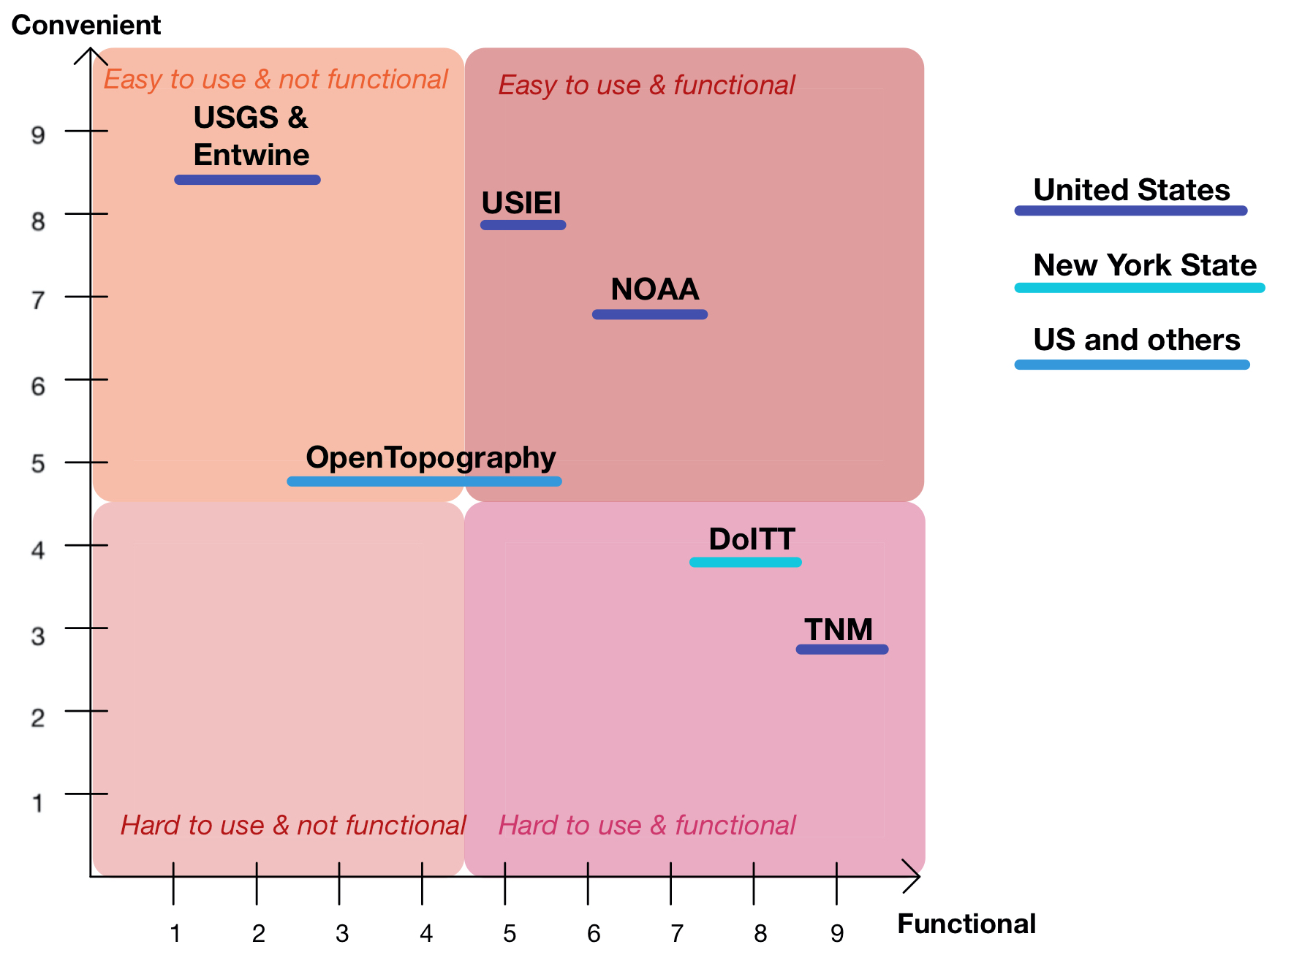

Figure 8: Overall score board for data retrieval GUIs

From observing both scoreboards in Figures 7 and 8 it can be inferred that a trend line would suggest that functionality and convenience are reversely proportional. This means that one of the challenges of creating a GUI is finding a balance between convenience and functionality - keeping the interface as simple as possible while maintaining all necessary tools.

Data types that can be explored for the data retrieval platforms are as follows. NOAA allows for specifying between imagery, land cover, and elevation. OpenTopography provides various options to choose from when searching for data. All of the available options can be seen in Figure 9.

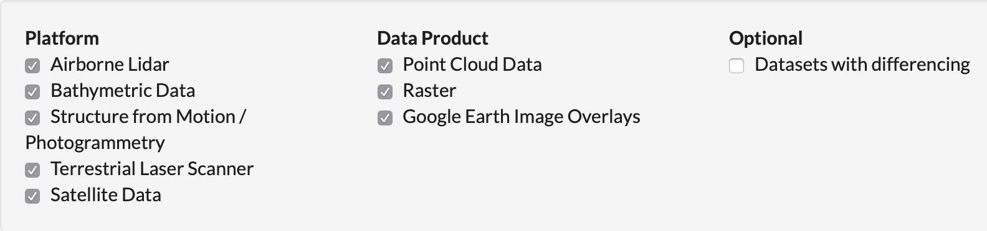

Figure 9: Data types available on OpenTopography [12]

USIEI also gives the option of specifying what kind of data the user is looking for. The types of data available can be seen in Figure 10.

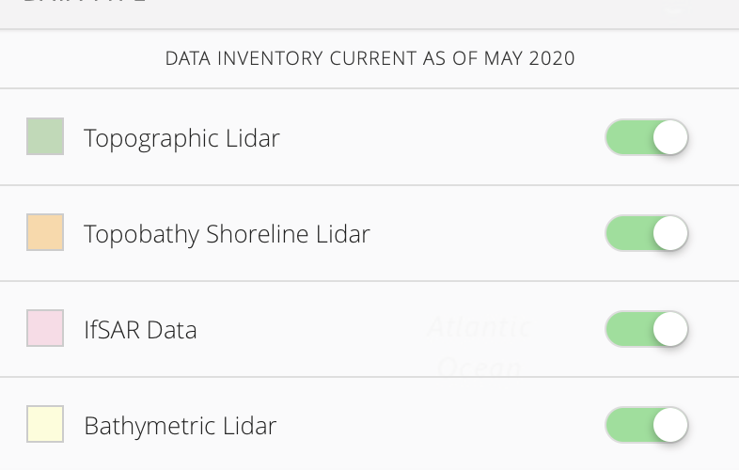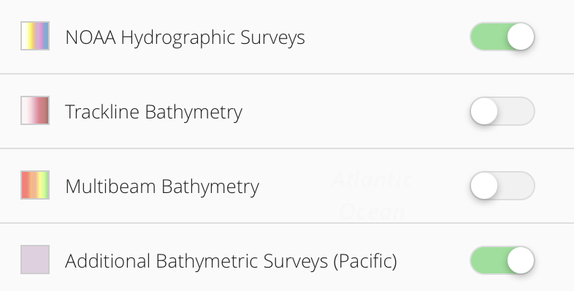

Figure 10: Data types available on USIEI [14]

Similarly, TNM provides a vast variety of possibilities that can be seen in Figure 11. Additionally, the user can specify the date of the data. Lastly, DoITT’s web page gives three options for data specification, DEM results, ORTHO results and LIDAR results. There is also an option of choosing the year that the data is from. When it comes to point cloud data, NOAA and OpenTopography offer different types of specifications that the users can choose when downloading the data. The options offered by NOAA can be seen in Figure 12. OpenTopography also offers various ways to customize the data. Their features can be seen in Figure 13.

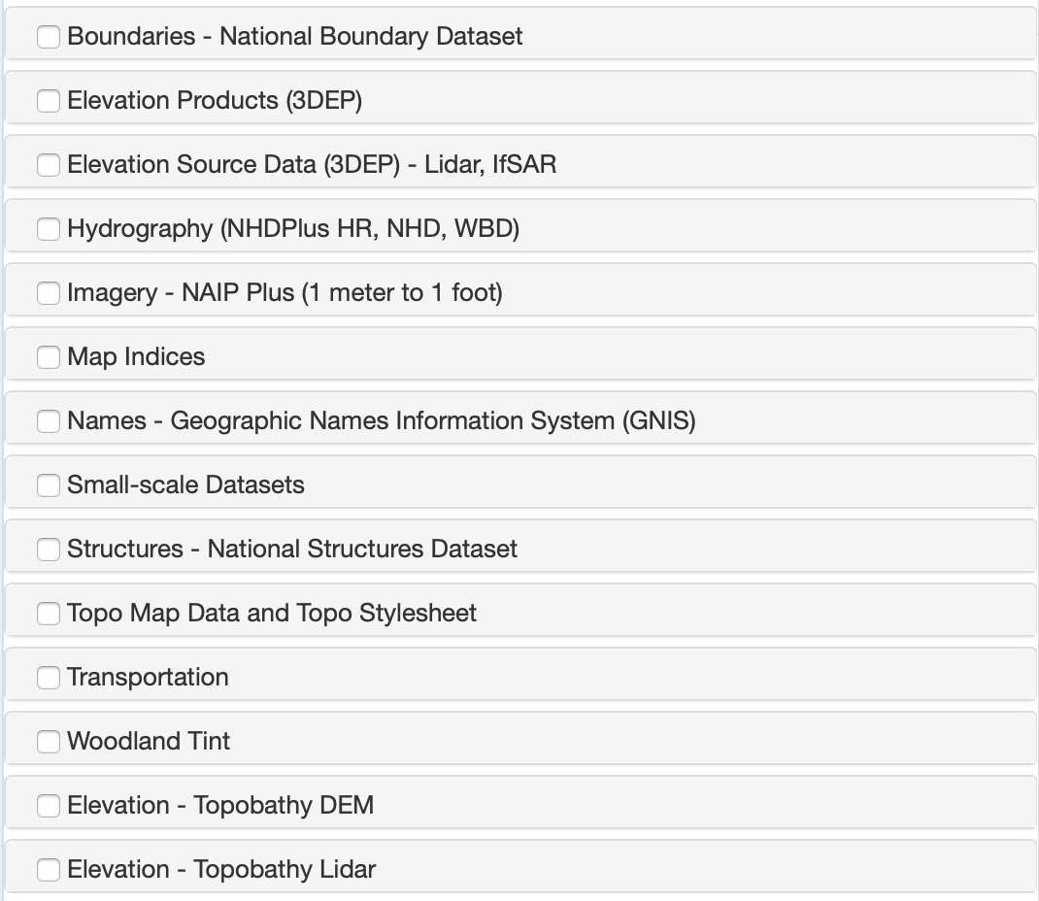

Figure 11: Data types available on TNM [13]

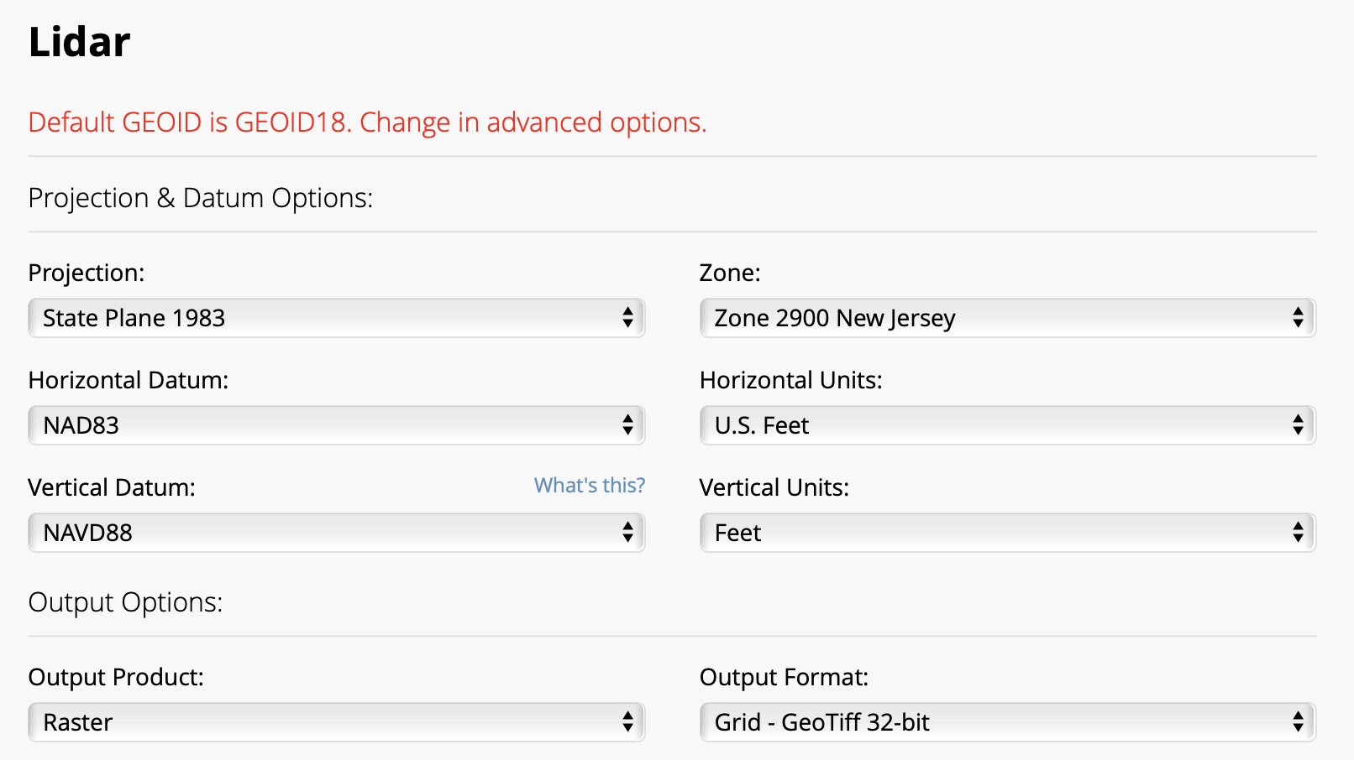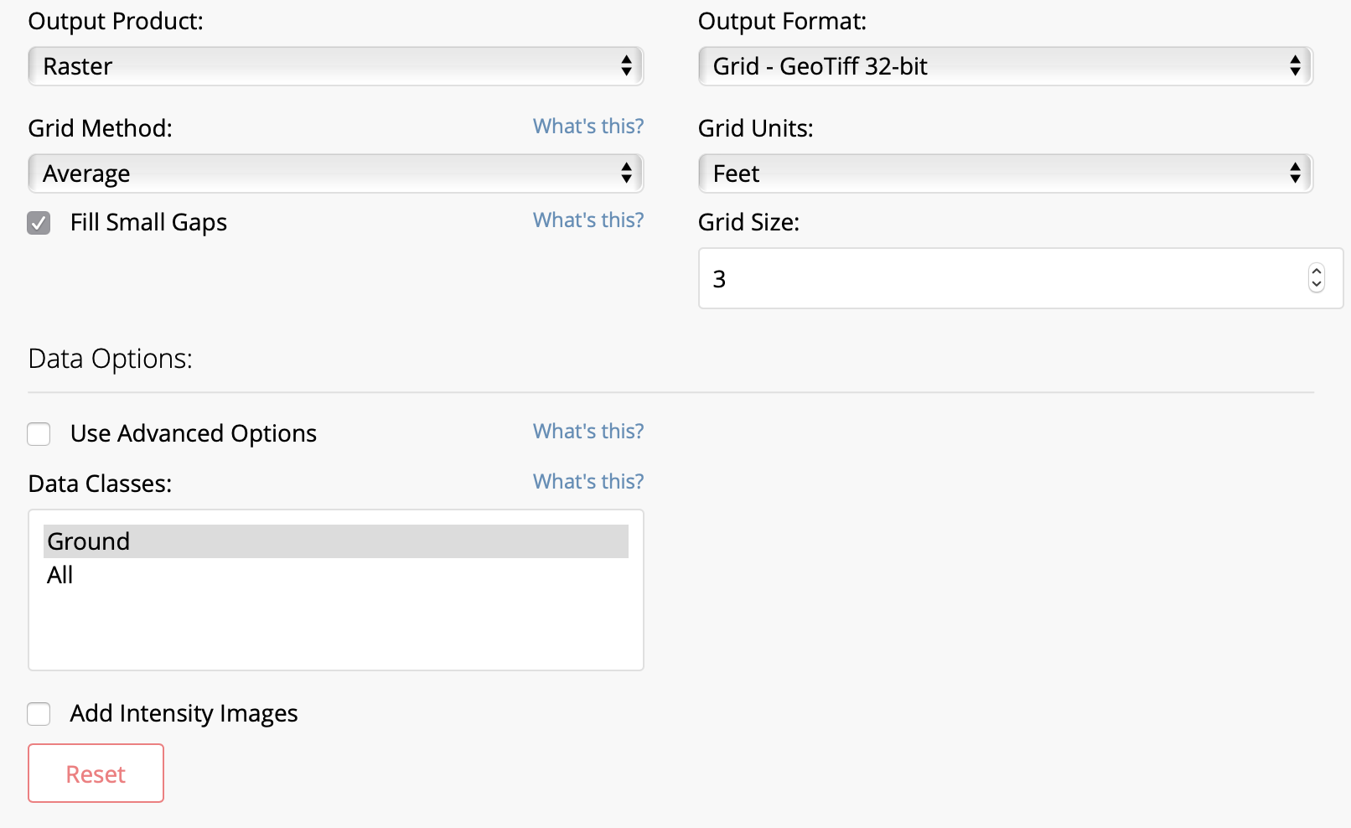

Figure 12: NOAA options for LiDAR data retrieval [15]

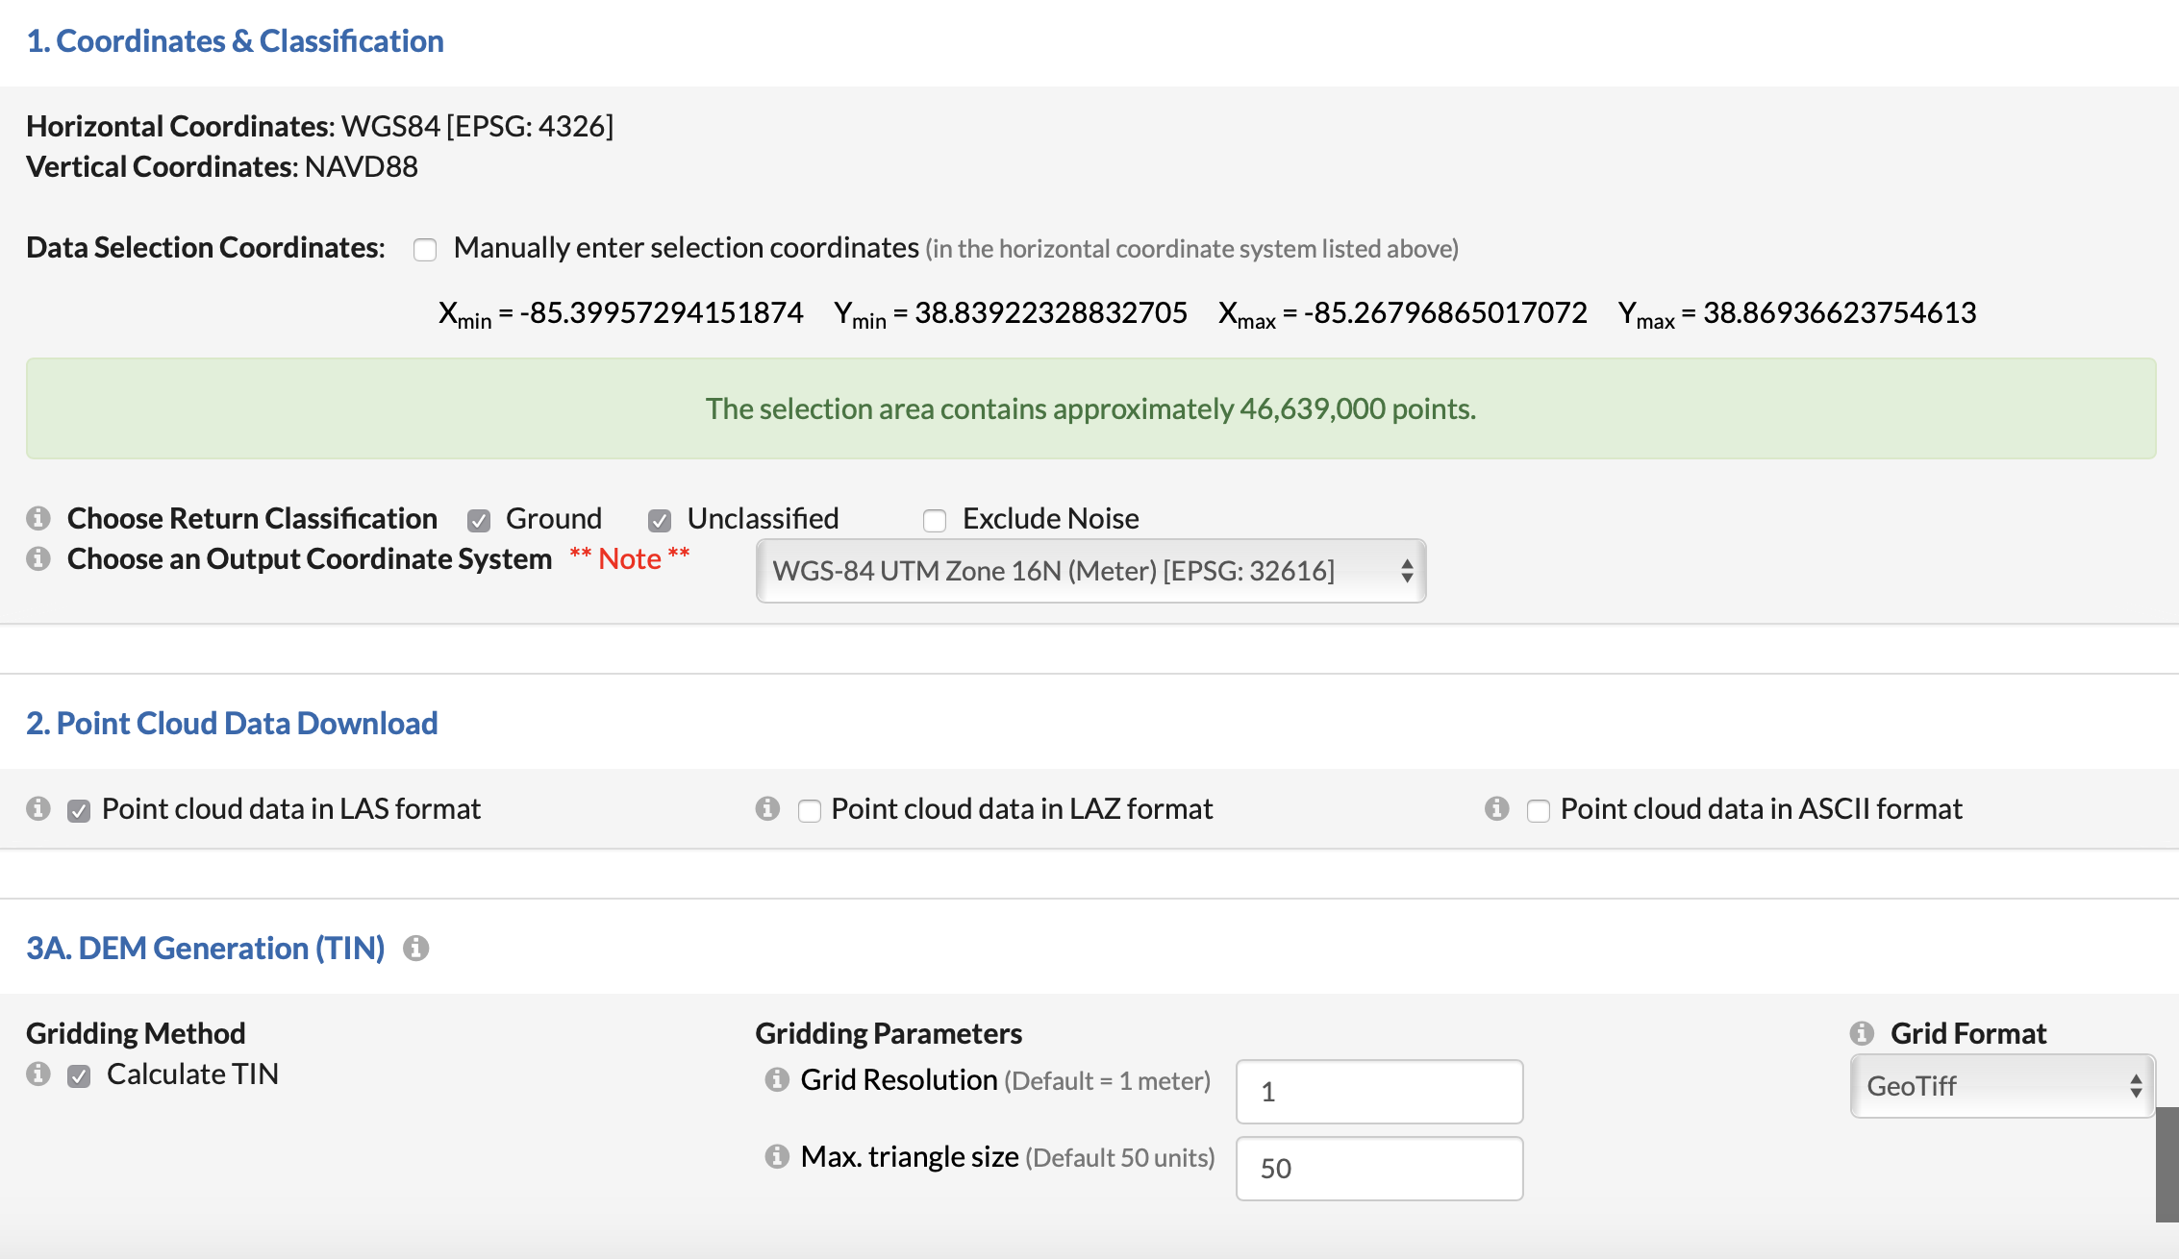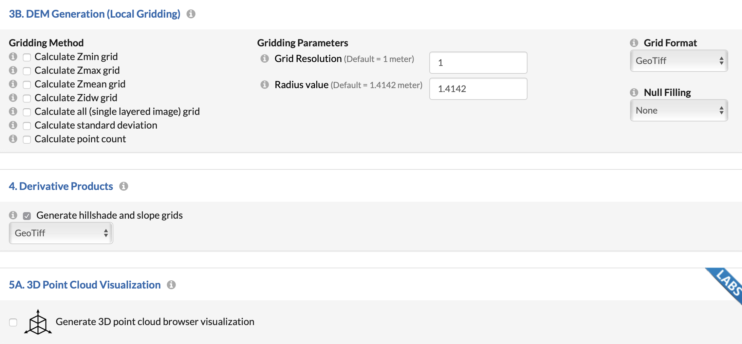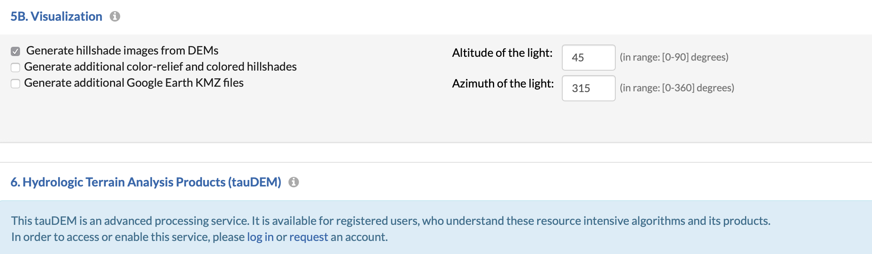

Figure 13: OpenTopography data customization options [12]

**Result**

From looking at all of the above mentioned platforms, some noteworthy features were identified and used in order to improve the current GUI prototype.

The first improvement made was adding an option for viewing and changing coordinates of points on the map. The intent was to make for a more accurate selection of the area of interest. There exists a GUI for data retrieval that provides this option - the USGS EarthExplorer [20]. The control panel from this application was used as a guide for the implementation of this tool. In Figure 14 you can see the USGS EarthExplorer GUI with the control panel that shows the coordinates of the three points on the map.

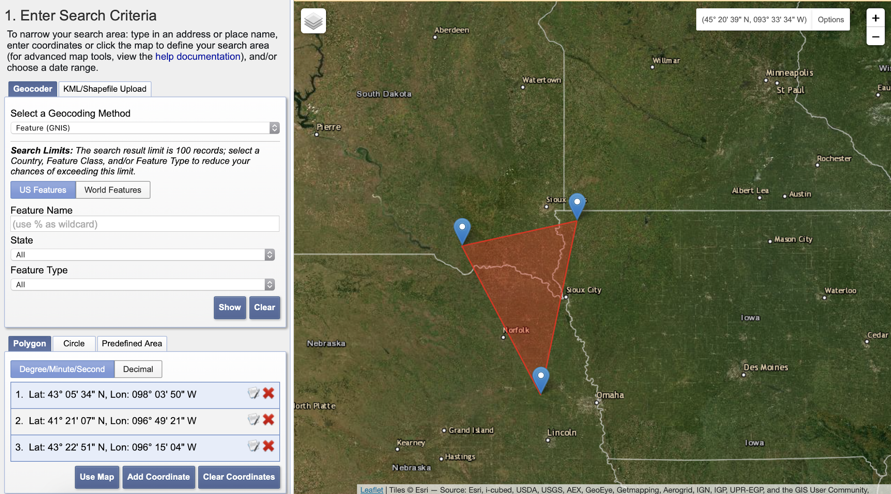

Figure 14: USGS EarthExplorer [16]

This application allows for adding and deleting as many points as possible and setting their latitude and longitude. Therefore, the user could achieve a rectangle as well as any polygon.

Since the previous prototype GUI offered two options - drawing a rectangle and drawing a polygon - this functionality was implemented for both of these options. When drawing a rectangle, the user can see coordinates of the top-left and the bottom-right points and can change the coordinates in order to change the location of the rectangle. The implemented feature can be seen in Figure 15. The polygon view allows for modification of coordinates of all points from the map and from the control panel. Additionally, the user can add and delete points from both map and control panel as well as mark points which makes for an easier way to keep track of them. This functionality can be seen in Figure 16. If the user selects the rectangle as a desired shape, the smallest area they could select by drawing on the map, while still being able to move the rectangle around is a square with a side of approximatelly 4.5 meters, which covers an area of around 20.25 square meters. If the user selects the polygon option and draws the shape on the map, they could select an area as small as an equilateral triangle whose sides are approximately 5m long, covering the area of around 10.82 square meters. The coordinates gathered from the map as well as a website for calculating distance between points [17] were used to obtain these numbers. The smallest possible rectangle and triangle drawing can be seen below in Figure 17. These restrictions only apply if the user draws the shape on the map. If they input the coordinates, there are no limitations to how accurate the placement of the shape can be. Additionally, a feature that allows for the user to upload a GeoJSON file instead of having to draw a shape on the map was developed. This feature supports the same tools as the polygon option. Therefore, the user can modify their uploaded GeoJSON shape if need be. The upload shape feature can be seen in Figure 18.

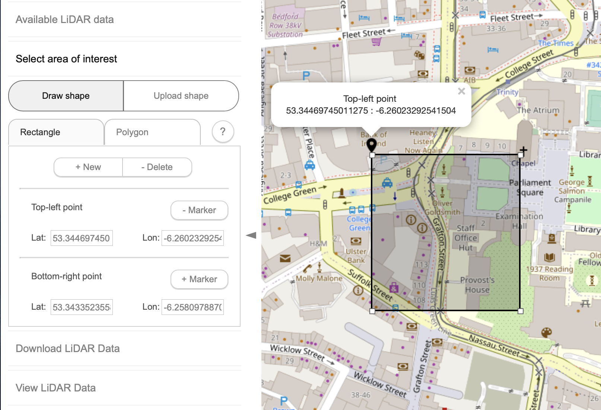

Figure 15: Rectangle view on the GUI

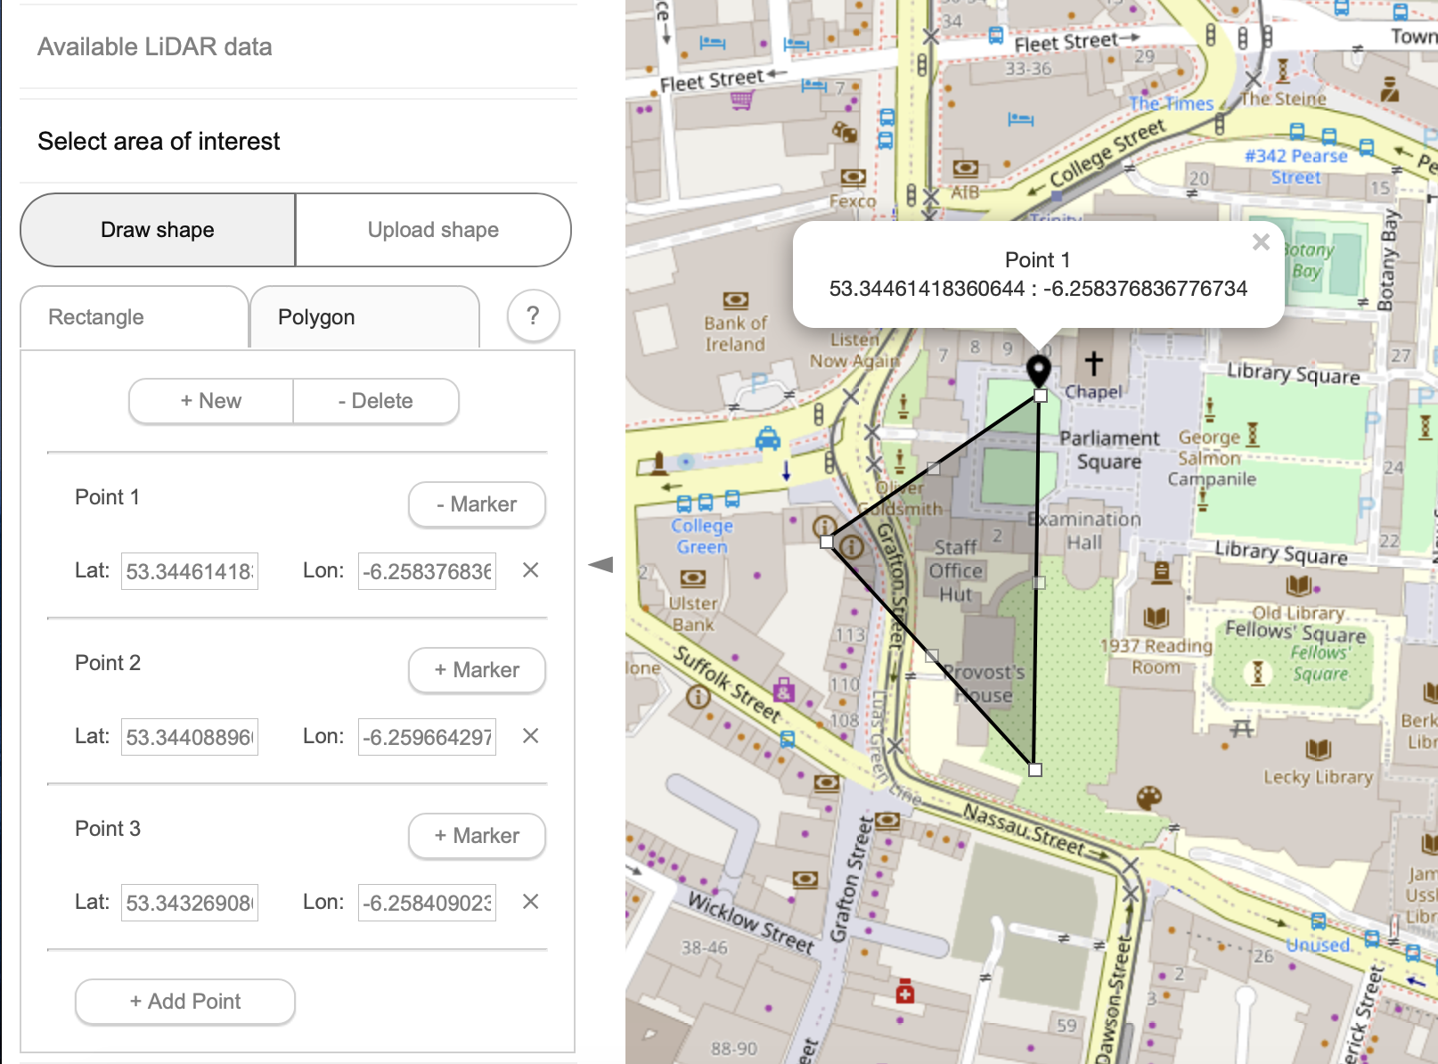

Figure 16: Polygon view on the GUI

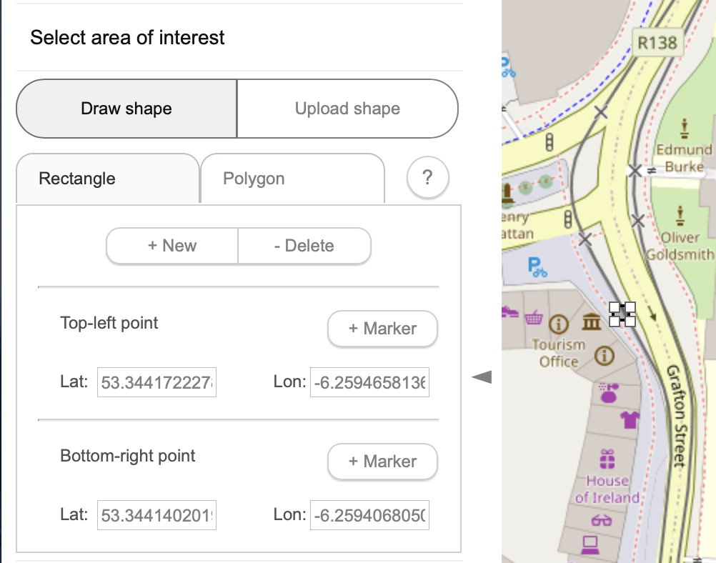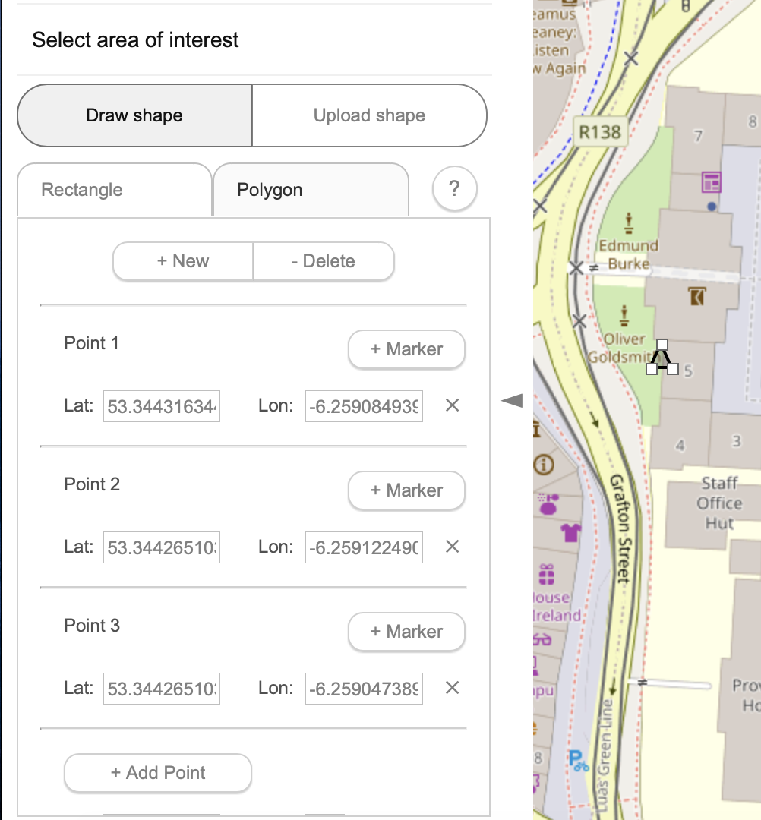

Figure 17: Drawing of smallest rectangle and triangle on the map

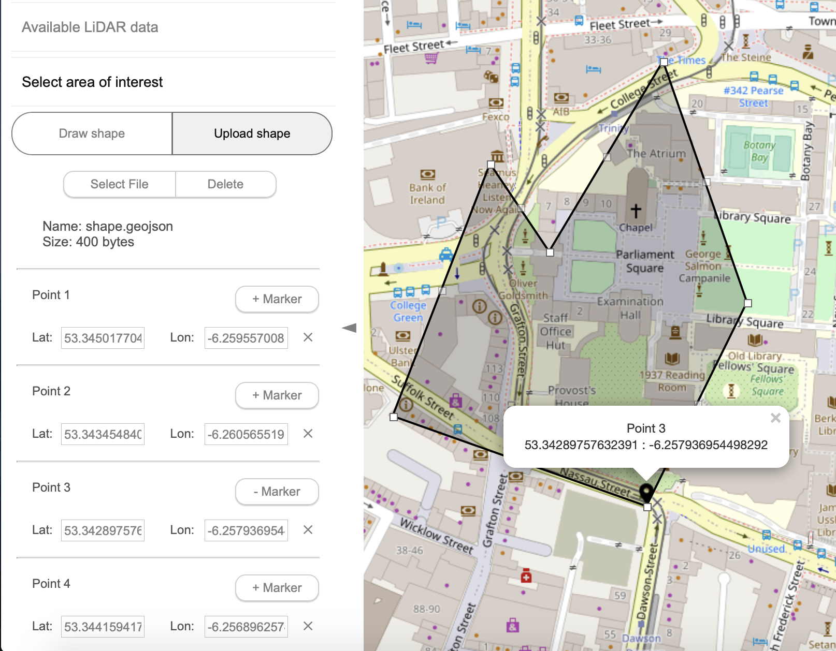

Figure 18: Upload GeoJSON shape functionality

As an additional feature, an option for downloading any shape that is currently on the map was added. The shape can be downloaded in the GeoJSON format for future use. The “Download” button was added for all three views - Rectangle, Polygon, and Upload Shape. This button can be seen circled in purple in Figure 17.

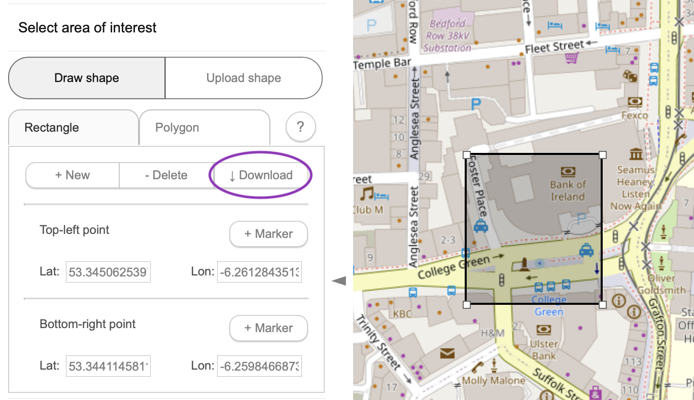

Figure 19: Download button in the rectangle view

A second improvement was picked from the features seen in explored GUIs. To make for a more user-friendly interface, a small tutorial section was created to explain each step that the user can take in order to use all the functionalities of the GUI. There are four main steps which correspond to the four main options on the GUI, which are “Available LiDAR data”, where the user can see datasets available in the region located by the map view. Additionally, the user can see all the formats that the data of each dataset are available in. After choosing the dataset they would like to retrieve data from, they can choose an area of interest by either drawing on the map or uploading a shape onto the map. This is explained in step two, under the option “Select area of interest”. After the user selects a desired area, they can download data in step three “Download LiDAR data” by choosing one of the available file formats. The file will automatically be downloaded onto their computer. Lastly, in step four, “View LiDAR data” the user has an option of uploading a file that they would like to view. The visualization is supported by Sketchfab, which is why the user has to have a sketchfab account, which is free. The information needed from the account in the API token, which needs to be imputed into the GUI, along with the file and the desired file name. The file under that name will automatically be uploaded onto the user’s Sketchfab account. They will be able to view the 3D model on the GUI. Open of the tutorial steps, as explained in the GUI, can be seen in Figure 20. Lastly, a help button was added to the “Draw Shape” section in order to explain the possible modifications the user can make to the shape from the map itself. The help button can be seen in Figure 21 circled in purple. The content of the help section can be found in Figure 22.

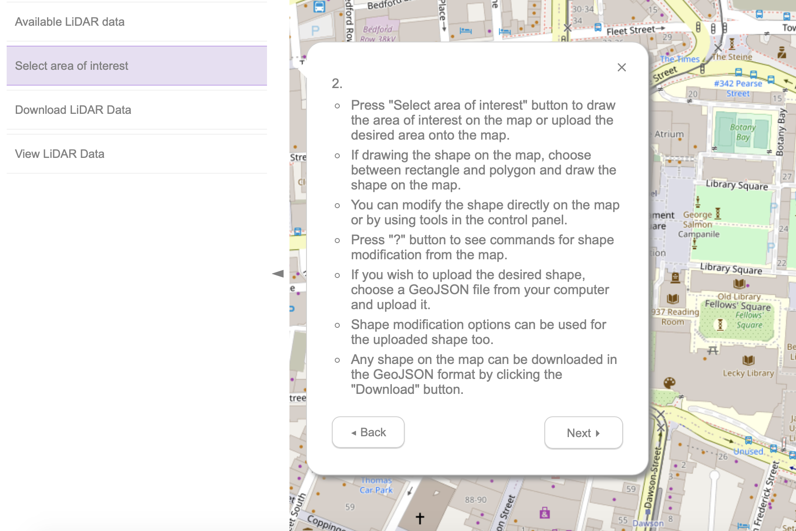

Figure 20: Step 2 as explained in the tutorial section of the GUI

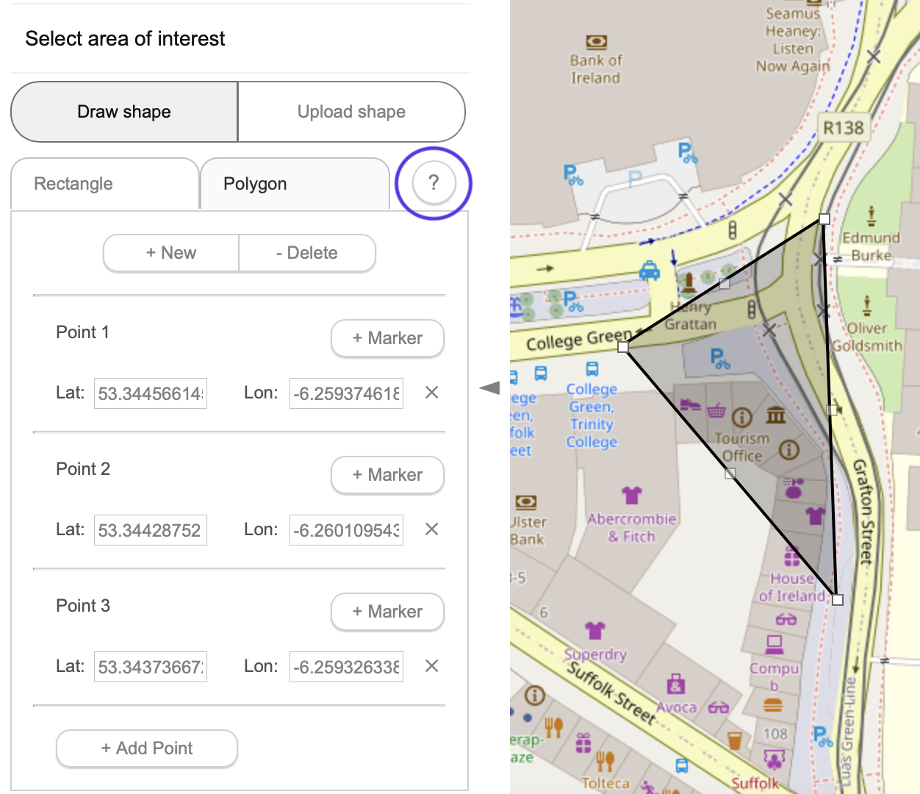

Figure 21: Help button for the draw shape functionality

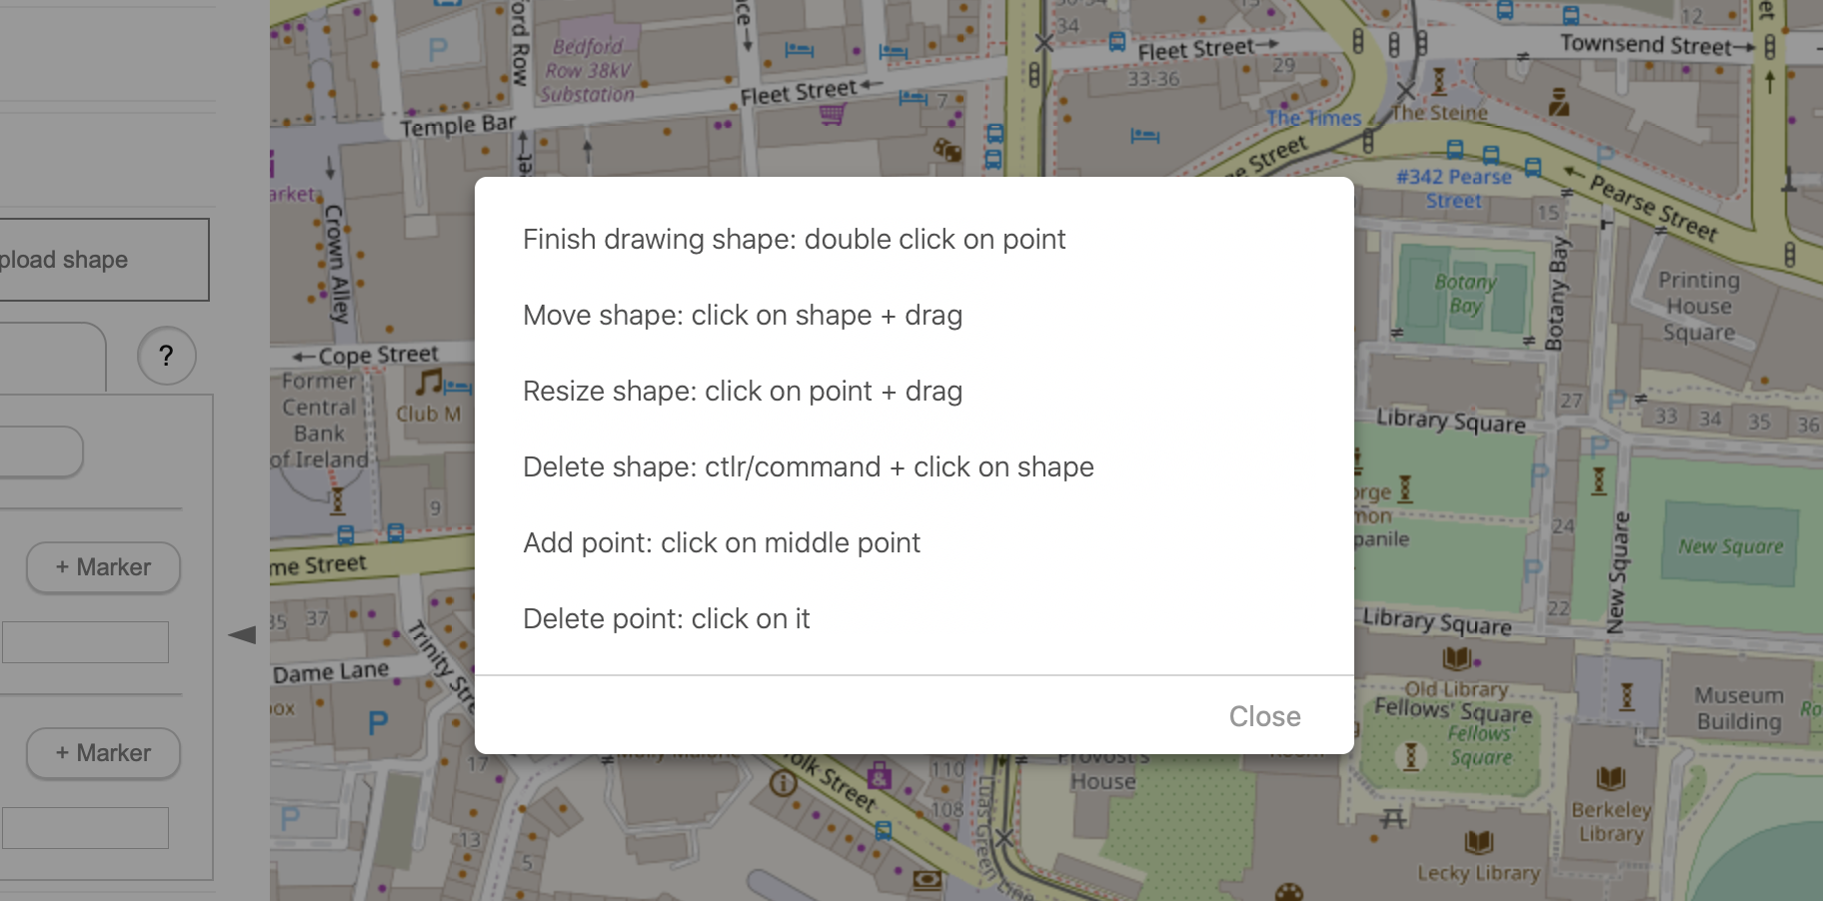

Figure 22: Content of the help message

From expecting available options for data customization, a collection of desired options for the GUI was observed and noted. The possible options for personalizing the products the user would get when downloading the data can be seen in the appendix. As one of the next steps in the project, these options were implemented into the front-end. Visualization of the options on the interface can be seen in Figure 23. In the future, queries for retrieving the data will be created and the connection between the back-end and the front-end will be established.

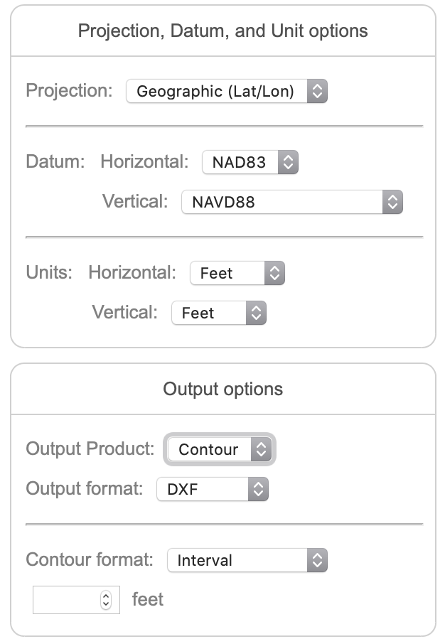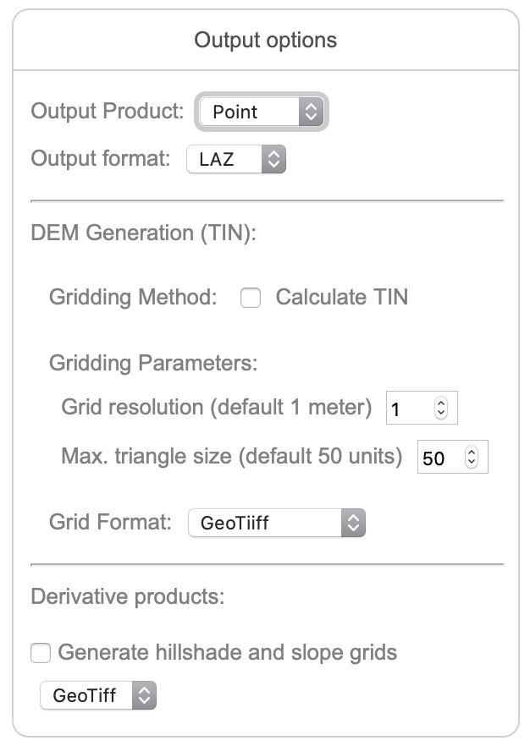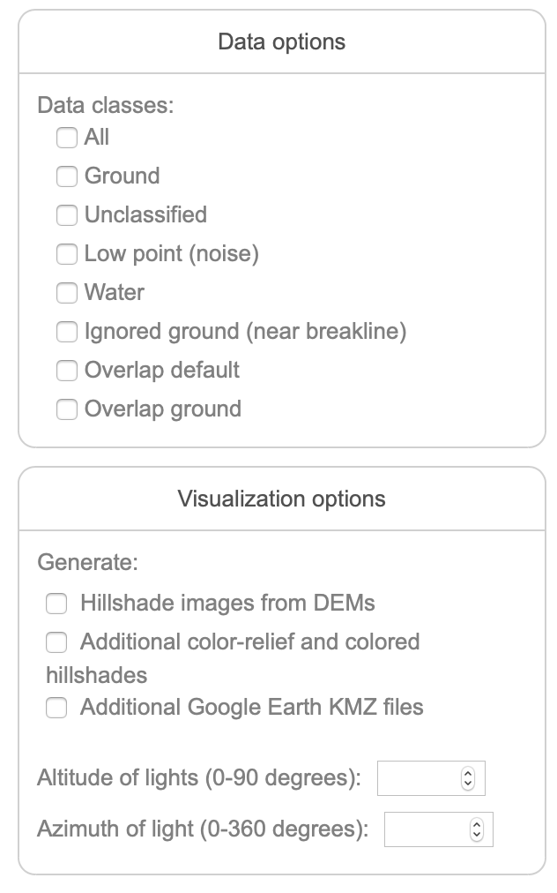

Figure 23: Possible options for data retrieval customization

**Discussion**

The point cloud data is stored in Apache HBase [18] which is a big data management system. HBase communicates with Apache Tomcat [19], a java servlet, which in turn receives requests from the front end. The Graphical User Interface (GUI) prototype was created using Leaflet [20], an open-source JavaScript library for interactive maps. For drawing the area of interest a Leaflet plugin, Leaflet.Editable [21], was used. It provided a rectangle and a polygon which could be drawn on the map by the user and modified or deleted afterwards. The GUI allows for data retrieval by using the map as well as data visualization by using Sketchfab [22], an online platform for 3D content publication. Users can see available data sets in the area they are currently looking at on the map. After they choose a data set, the user can select an area of interest by drawing or uploading a shape onto the map. If they choose to draw a shape, they can choose between a rectangle and a polygon. If they choose to upload a shape onto the map, they can select a GeoJSON file in order to do so. The desired shape can be modified as many times as necessary. After the desired are has been select, the user can download data and view it by using their Sketchfab account. The interface can be seen in Figure 24, where the blue area represents the position of the available data set and the area of interest can be seen in black. After selecting the area of interest, the user can download the data corresponding only to that area which reduces the amount of data being retrieved dramatically. Then, the user can upload the data to Sketchfab through the GUI and view the 3D model. An example of a 3D model on Sketchfab can be seen in Figure 25.

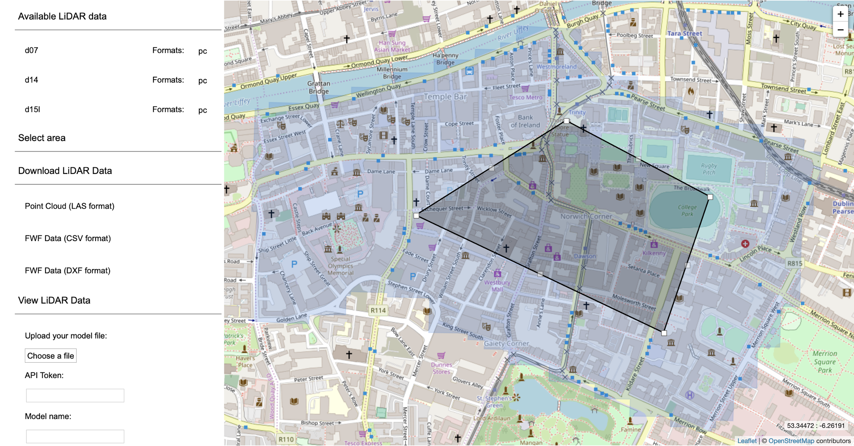

Figure 24: GUI main page with available data set (blue) and selected are of interest (black)

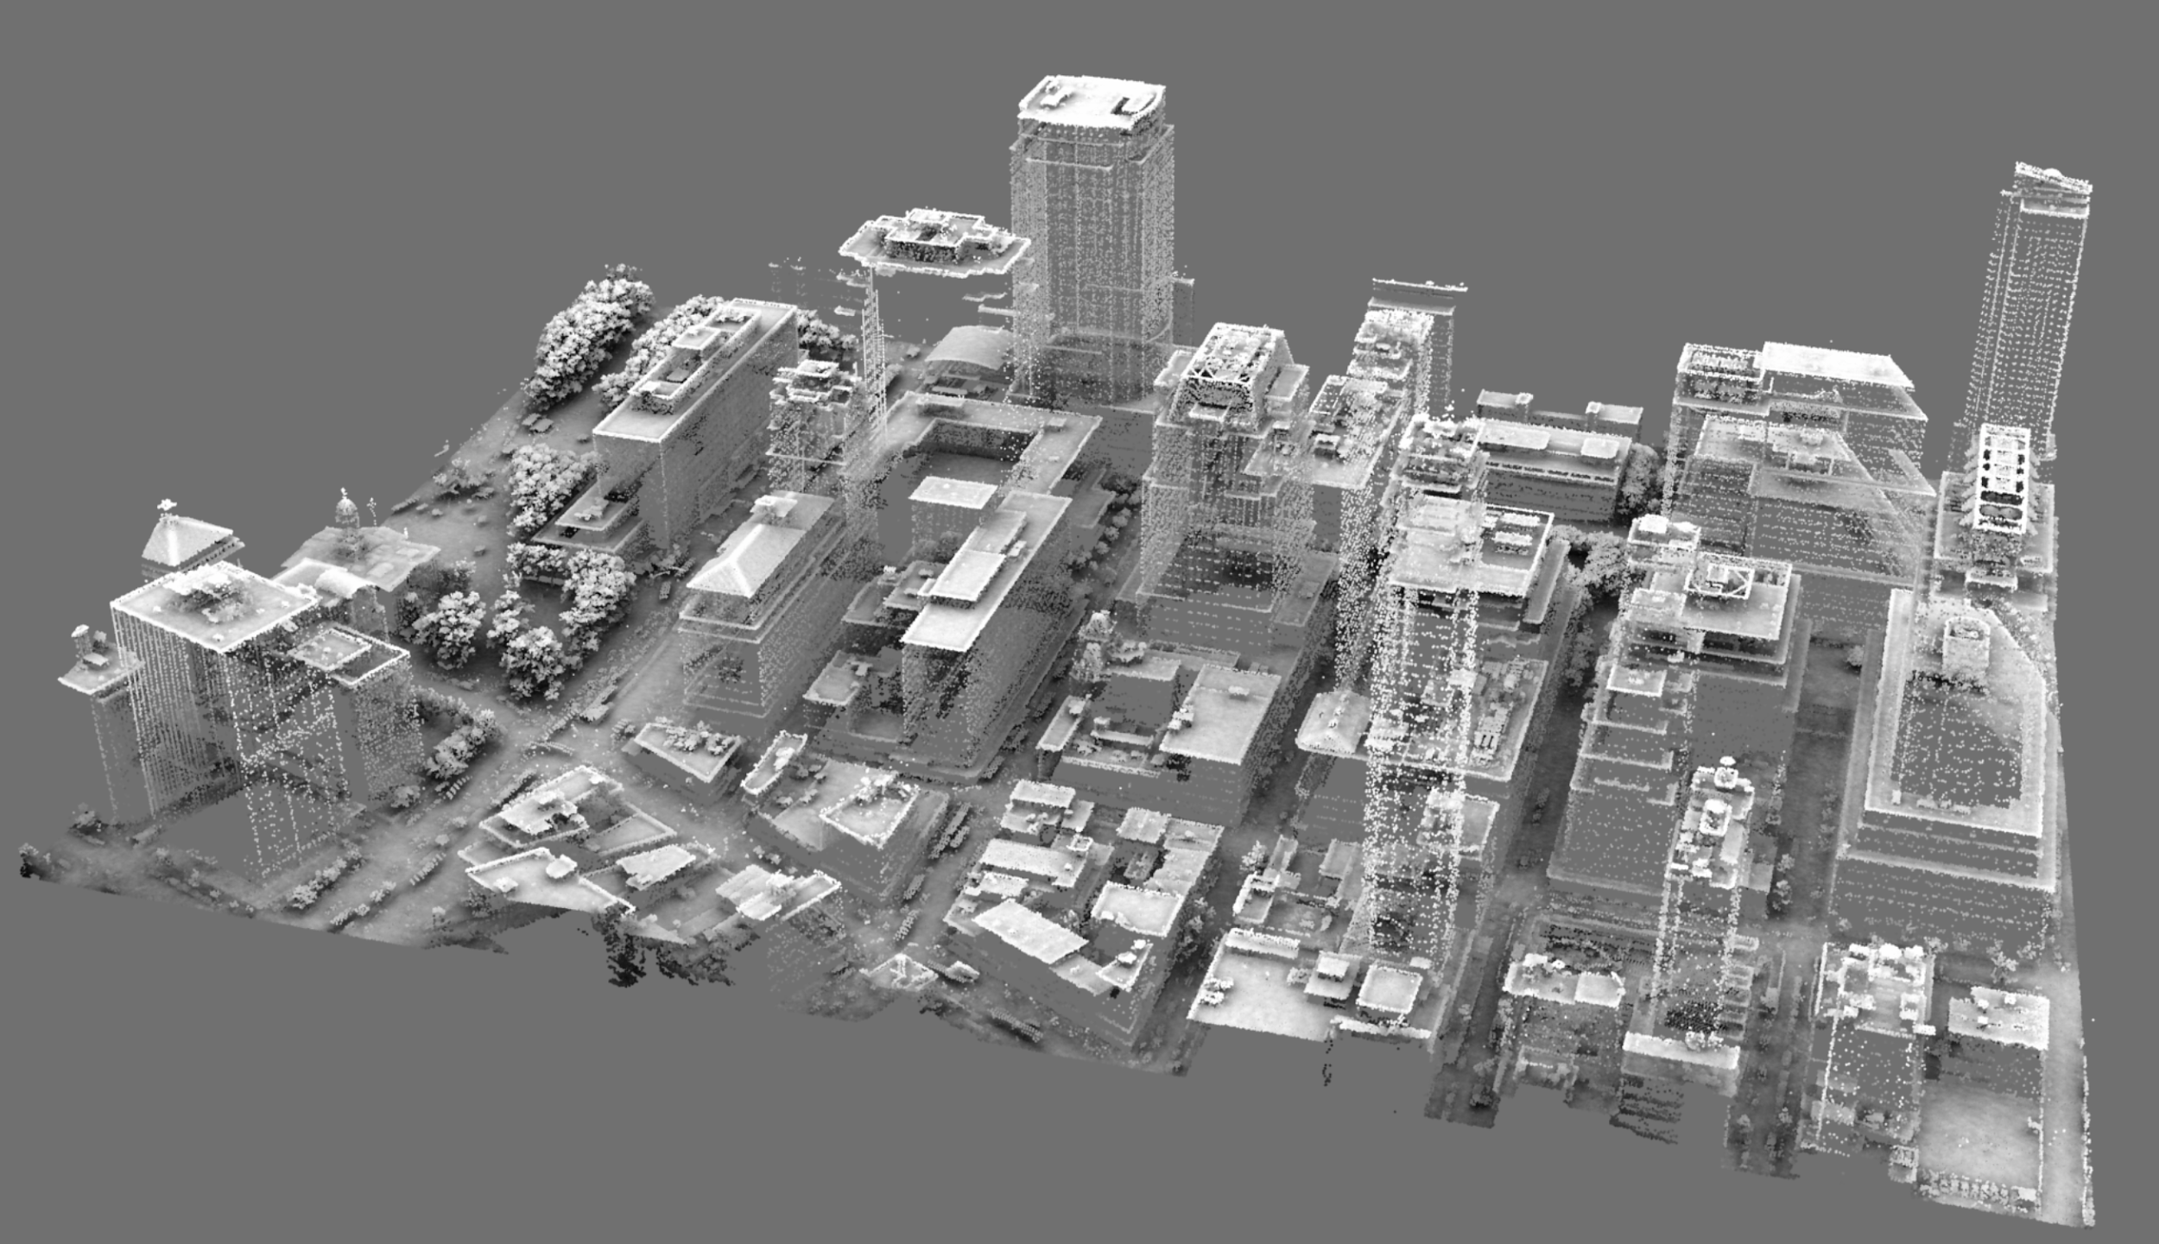

Figure 25: 3D model in Sketchfab viewer [23]

**Conclusion**

LiDAR data has become very important because of its beneficial applications. In order to utilize it, massive data sets need to be retrieved from the database and viewed by using a specific visualization platform. Because of the increase in LiDAR data usage, many platforms for LiDAR data retrieval have been created. Most of these platforms utilize strategies for data management, but do not offer the option of retrieving only the necessary data. This is why a platform that consists of tools which are meant to provide an accurate and personalized point retrieval was created. In the future, the platform is hoped to prove the users with a more user-friendly interface by expanding the tutorial section of the interface and providing videos that showcase the use of the functionalities. Additionally, the “Download LiDAR data” section will be expanded in order to provide more options for customizing the products that users receive when downloading the data.

**Appendix**

1. Projection, datum and unit options:

|  |  |  |  |  |
| --- | --- | --- | --- | --- |
| **Projection options** | **Datum options** | | **Unit options** | |
| State Plane 1983 | **Horizontal** | **Vertical** | **Horizontal** | **Vertical** |
| State Plane 1927 | NAD83 | NAVD88 | Feet | Feet |
| Albers CONUS/USGS |  | GRS80/NAD83 Ellipsoid | Meters | Meters |
| UTM |  | NGVD29 |  |  |
| Geographic(Lat/Lon) |  |  |  |  |

1. Output options:

|  |  |  |
| --- | --- | --- |
| **Output product** | | |
| **Point** | **Contour** | **Raster** |
| **Output format** | | |
| LAZ | DXF | ASCII |
| LAS | Shapefile | Floating Pt. |
| ASCII |  | GeoTiff 32-bit |
|  |  | Imagine |

* Point options:

|  |  |  |  |
| --- | --- | --- | --- |
| **DEM generation (TIN)** | | | **Derivative products** |
| **Gridding method** | **Grinding parameters** | **Grid format** | Generate hillshade and slope grids |
| Calculate TIN | Grid resolution (meters) | ASCII | **Format:** |
|  | Max.triangle size (units) | IMG | IMG |
|  |  | GeoTiff | GeoTiff |

* Contour options:

|  |
| --- |
| **Contour format** |
| Interval |
| Single Elevation |

**Pick a value of interval/single elevation (feet)**

* Raster options:

|  |
| --- |
| **Grid method** |
| Average |
| IDW |
| Maximum |
| Minimum |
| Spline |
| TIN |

**Pick grid size (feet)**

|  |
| --- |
| **Layer types and additional SRTM data** |
| Digital Terrain Model (DTM) |
| Include Global 30m SRTM data |

1. Data options:

|  |
| --- |
| **Data classes** |
| All |
| Unclassified |
| Ground |
| Low point (noise) |
| Water |
| Ignored ground (near breakline) |
| Overlap default |
| Overlap ground |

1. Visualization options:

|  |  |
| --- | --- |
| **Generate** | **Pick** |
| Hillshade images from DEMs | Altitude of light (0-90 degrees) |
| Additional color-relief and colored hillshades | Azimuth of light (0-360 degrees) |
| Additional Google Earth KMZ files |  |

**Resources**

[1] Lidar 101: An Introduction to Lidar Technology, Data, and Applications. Accessed July 26, 2020. [Online]. Available: https://coast.noaa.gov/data/digitalcoast/pdf/lidar-101.pdf

[2] Sketchfab, “Merrion Sq North”. Accessed August 3, 2020. [Online]. Available: https://sketchfab.com/3d-models/merrion-sq-north-ff7a4afa40fe496e802941cec74b8cd8

[3] 3D Elevation Program (3DEP), USGS. Accessed June 16, 2020. [Online] Available: <https://www.usgs.gov/core-science-systems/ngp/3dep/broad-agency-announcements?qt-science_support_page_related_con=3#qt-science_support_page_related_con>

[4] USGS & Entwine. Accessed June 16, 2020. [Online] Available: <https://usgs.entwine.io>

[5] Discover GIS Data NY, NYS DoITT. Accessed June 16, 2020. [Online] Available: [https://orthos.dhses.ny.gov/#](https://orthos.dhses.ny.gov/)

[6] AHN2 pointcloud viewer. Accessed June 16, 2020. [Online] Available: <http://ahn2.pointclouds.nl/#?camera_x=140183.36973145982&camera_y=351353.9722696242&camera_z=80588.82034192&lookat_x=140176.50197337763&lookat_y=351412.5714400772&lookat_z=80508.08019647104>

[7] Potree, GitHub. Accessed June 16, 2020. [Online] Available:

<https://github.com/potree/potree/>

[8] speck.ly. Accessed June 16, 2020. [Online] Available: <http://dev.speck.ly/?s=0&r=ept%3A%2F%2Fs3-us-west-2.amazonaws.com%2Fusgs-lidar-public%2FAK_BrooksCamp_2012&ca=0&ce=40&ct=-17334459%2C8078264.5%2C486.5&cd=12908.633&cmd=51634.533&ps=2&pa=0.1&ze=1&c0s=remote%3A%2F%2Fimagery%3Furl%3Dhttp%253A%252F%252Fserver.arcgisonline.com%252FArcGIS%252Frest%252Fservices%252FWorld_Imagery%252FMapServer%252Ftile%252F%257B%257Bz%257D%257D%252F%257B%257By%257D%257D%252F%257B%257Bx%257D%257D.jpg>

[9] plas.io. Accessed June 16, 2020. [Online] Available: <https://plas.io>

[10] Online LiDAR point cloud viewer. Accessed June 16, 2020. [Online] Available: <http://lidarview.com>

[11] CloudCompare - Open Source project. Accessed June 16, 2020. [Online] Available: <https://www.cloudcompare.org>

[12] OpenTopography. Accessed June 17, 2020. [Online] Available: <https://portal.opentopography.org/datasets?minX=-74.6375041423778&minY=41.02961337931481&maxX=-73.44915441322786&maxY=41.44206140400999>

[13] TNM Download. Accessed June 17, 2020. [Online] Available: <https://viewer.nationalmap.gov/basic/#productGroupSearch>

[14] United States Interagency Elevation Inventory. Accessed June 17, 2020. [Online] Available: <https://coast.noaa.gov/inventory/>

[15] NOAA: Data Access Viewer. Accessed June 17, 2020. [Online] Available: <https://coast.noaa.gov/dataviewer/#/lidar/search/-8261298.490790479,4809015.330976226,-8259796.025453248,4810223.991485985>

[16] UGSG EarthExplorer. Accessed June 18, 2020. Available: <https://earthexplorer.usgs.gov>

[17] Calculate distance and bearing between Latitude/Longitude points, Movable Type Scripts. Accessed July 3, 2020.Available: <https://www.movable-type.co.uk/scripts/latlong.html>

[18] Apache HBase. Accessed June 16, 2020. [Online] Available: https://hbase.apache.org

[19] Apache Tomcat. Accessed June 16, 2020. [Online] Available: <http://tomcat.apache.org>

[20] Leaflet. Accessed June 16, 2020. [Online] Available: <https://leafletjs.com>

[21] Leaflet.Editable, Github. Accessed June 18, 2020. Available: <https://github.com/Leaflet/Leaflet.Editable>

[22] Sketchfab. Accessed June 16, 2020. [Online] Available: <https://sketchfab.com/feed>

[23] 370 Jay St., Brooklyn, New York, Sketchfab. Accessed June 16, 2020. [Online] Available: <https://sketchfab.com/3d-models/370-jay-st-brooklyn-new-york-03a7b654a00f4e10a86a50fda5ab24ca>